Convert and upload UDI data by Excel – Version 2025/01
Table of contents

1 Convert and upload UDI data by Excel – Version 2025/01 1
2 Change history 2
3 Support und contact information 2
4 Convert 3
5 Upload to the GUDI add-on 5

Change history

Version | Date | User | Description

Support und contact information

A support request is usually made by e-mail. In urgent cases you can call us.

E-Mail: support@europe-it-consulting.ch

Phone: +41 61 508 73 34

Web: https://www.europe-it-consulting.ch

Address:

EUROPE IT Consulting GmbH
Steinentorstrasse 35
4051 Basel
Switzerland

Convert
To open the converter program please write /n/UDW/CONVERT and tab enter.
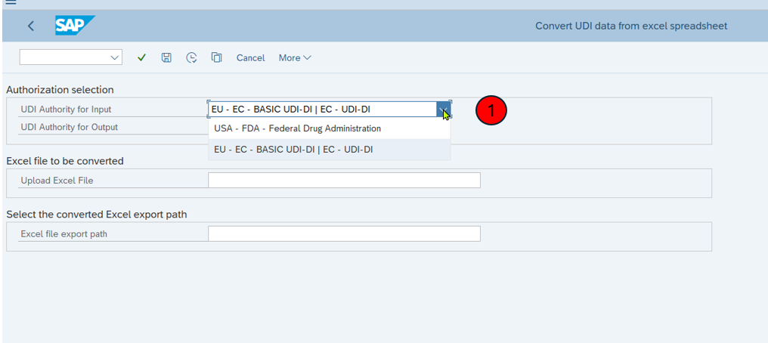
- Choose the Value of UDI Authority for Input:
- for EUDAMED: EU – EC - Basic UDI-DI / EC – UDI-DI
- for GUDID: USA – FDA – Federal Drug Administration
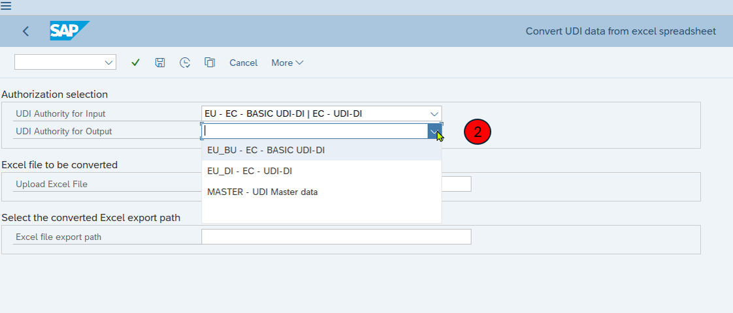
- Choose UDI Authority for Output:
- If you choosed under 1: EU – EC - Basic UDI-DI / EC – UDI-DI, then you have now the possibilities to convert the data to Basic UDI-DI, UDI-DI and Master UDI
- If you choosed under 1: USA FDA – Federal Drug Administration, then you have now the possibilities to convert the data to UDI for FDA and Master UDI
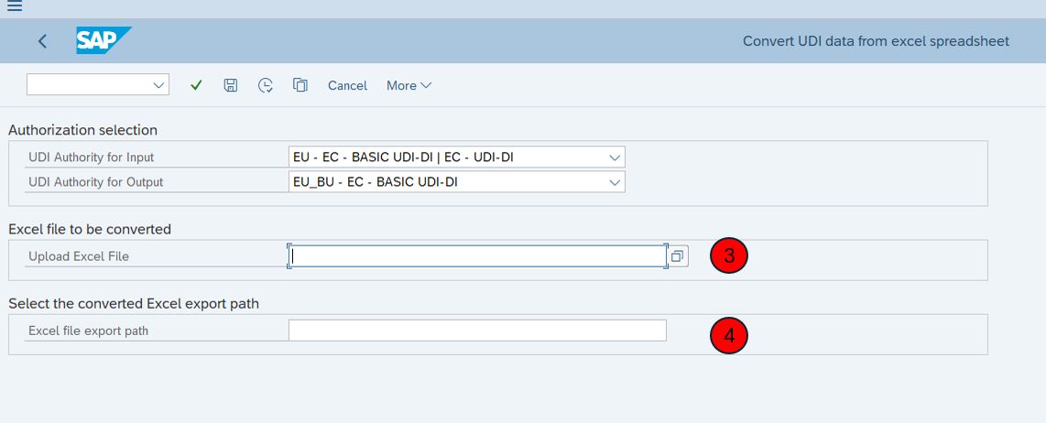
- Please upload now the Excel Template with your UDI date
- Please select the folder, in which you want to save converted data
- To execute, please click on your keyboard F8.

- After the program converted your file, you will see at the bottom a notice with the path and the name of the excel file
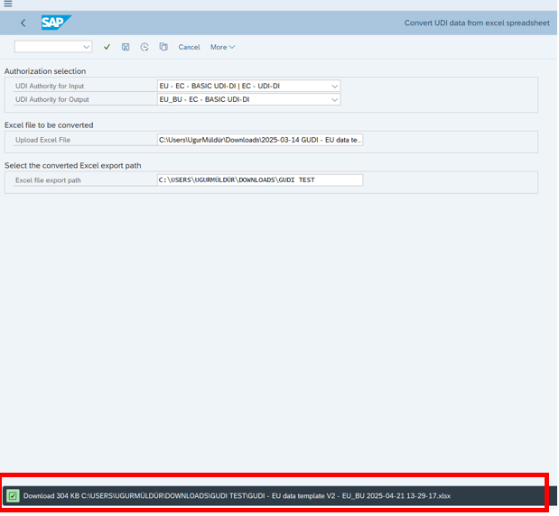
Please repeat the steps to convert your UDI data to UDI-DI and Master UDI as well.

Upload to the GUDI add-on
To open the upload application please write /n/UDW/UPLOAD and tab enter.
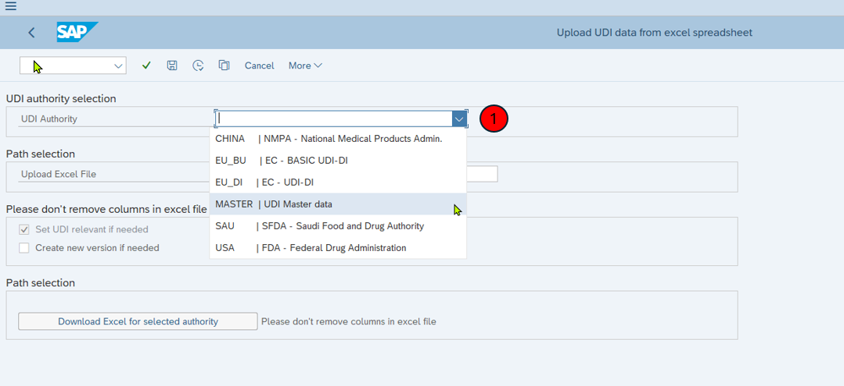
- Please select the UDI Authority.
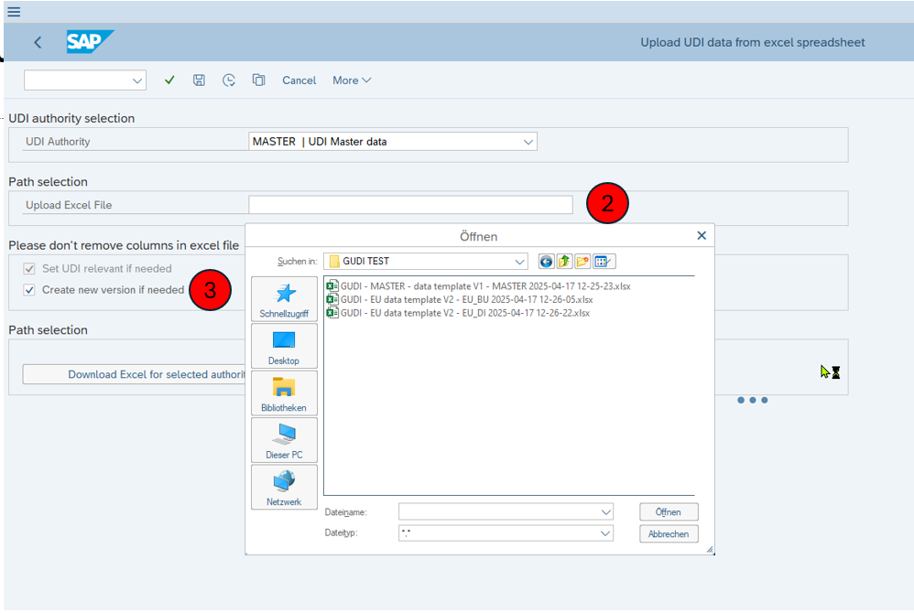
- Please select the converted file:
- If you choosed under 1: Master UDI, then you need to select the GUDI -MASTER – data template
- Click on Create new version if need
- Execute with F8 please.
When the process is finished, a new window opens automatically. This will give you information on which data has been successfully uploaded and also which are not, including the reason, why
