Create new UDI and Basic UDI – Version 2025/01
Table of contents

1 Create new UDI and Basic UDI – Version 2025/01 1
2 Change history 3
3 Support und contact information 3
4 Introduction 4
UDI data management process 4
5 Master UDI 5
5.1 Set Master UDI relevant 5
5.2 Create New version of Master UDI 6
5.3 Maintain Master UDI 7
5.4 Start release Workflow of Master UDI 13
5.5 Release Master UDI Data 14
6 EUDAMED Basic UDI-DI 15
6.1 Create New Basic UDI-DI 15
6.1.1 Valid from 16
6.1.2 Device 16
6.1.3 System or Procedure Pack 18
6.1.4 Attributes 19
6.1.5 Certificate Links 20
6.1.6 Clinical Investigation Links 21
6.1.7 Indication of Medical Purpose 21
6.1.8 Validation 22
6.1.9 Save & Close 23
6.2 Start Release Workflow of Basis UDI-DI 24
6.3 Release the Basic UDI-DI 25
7 EUDAMED UDI-DI 26
7.1 Set UDI-DI Relevance 26
7.2 Create New Version of UDI-DI 27
7.3 Maintain UDI-DI 29
7.3.1 Device (Connect with Basic UDI) 29
7.3.2 Additional Identifiers 31
7.3.3 Attributes 31
7.3.4 Direct Marketing 32
7.3.5 Production Information 33
7.3.6 Trade Name 33
7.3.7 EMDN 34
7.3.8 Additional Description 35
7.3.9 Information on substances 35
7.3.10 CMR/Endocrine disruptor 36
7.3.11 Market Information 36
7.3.12 Critical Warning 37
7.3.13 Clinical Sizes 37
7.3.14 Storage & Handling 38
7.3.15 Packaging Hierarchy 38
7.3.16 Validation 39
7.3.17 Save 40
7.4 Start Release Workflow of UDI-DI 41
7.5 Release the UDI-DI 42
7.6 Data submission 43

Change history

Version | Date | User | Description

Support und contact information

A support request is usually made by e-mail. In urgent cases you can call us.

E-Mail: support@europe-it-consulting.ch

Phone: +41 61 508 73 34

Web: https://www.europe-it-consulting.ch

Address:

EUROPE IT Consulting GmbH
Steinentorstrasse 35
4051 Basel
Switzerland

Introduction

Dieses Dokument soll Ihnen Schritt für Schritt das Anlegen einer Master UDI, eines neuen Basic UDI-DI und UDI-DI, sowie die Übertragung zur EUDAMED erklaeren.

UDI data management process

This roadmap outlines the steps needed to manage your data efficiently and successfully. Initially, you'll start in the UDI Master Plugin to maintain common data within this menu. After initiating the release workflow, you'll choose the Authority (and consequently, the plugin) to which you wish to submit the UDI data later.
In the selected EUDMAED plugin, you'll then maintain the specific data of the authority. The common data will be automatically uploaded from the master data to the plugin.
After completing these steps, the only task left is to transfer and submit your data to the authorities through the UDI Data submissions process.
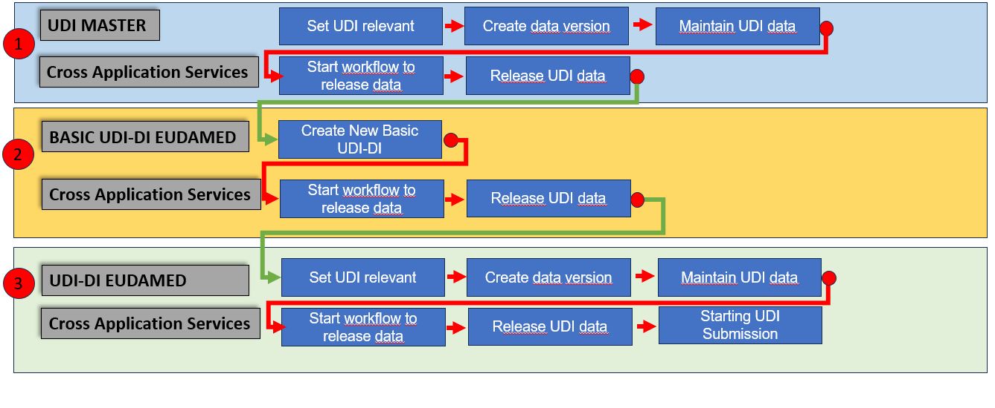
Roadmap of UDI Data Management

Master UDI

Set Master UDI relevant

To begin the UDI data management process, the first step is to activate the material as UDI relevant. This step is crucial to ensure the subsequent provision of the necessary UDI information.

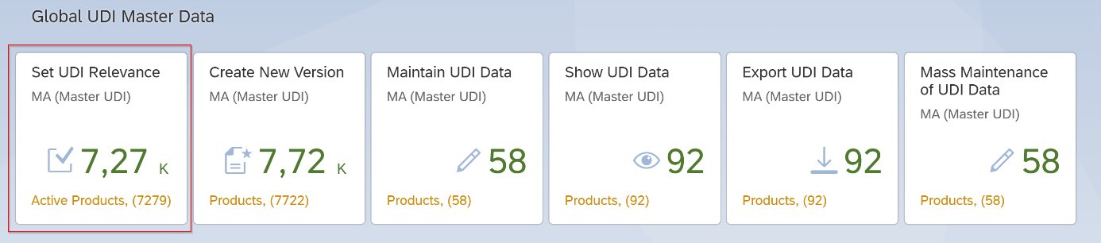
- Access the "Set UDI Relevance" Application.

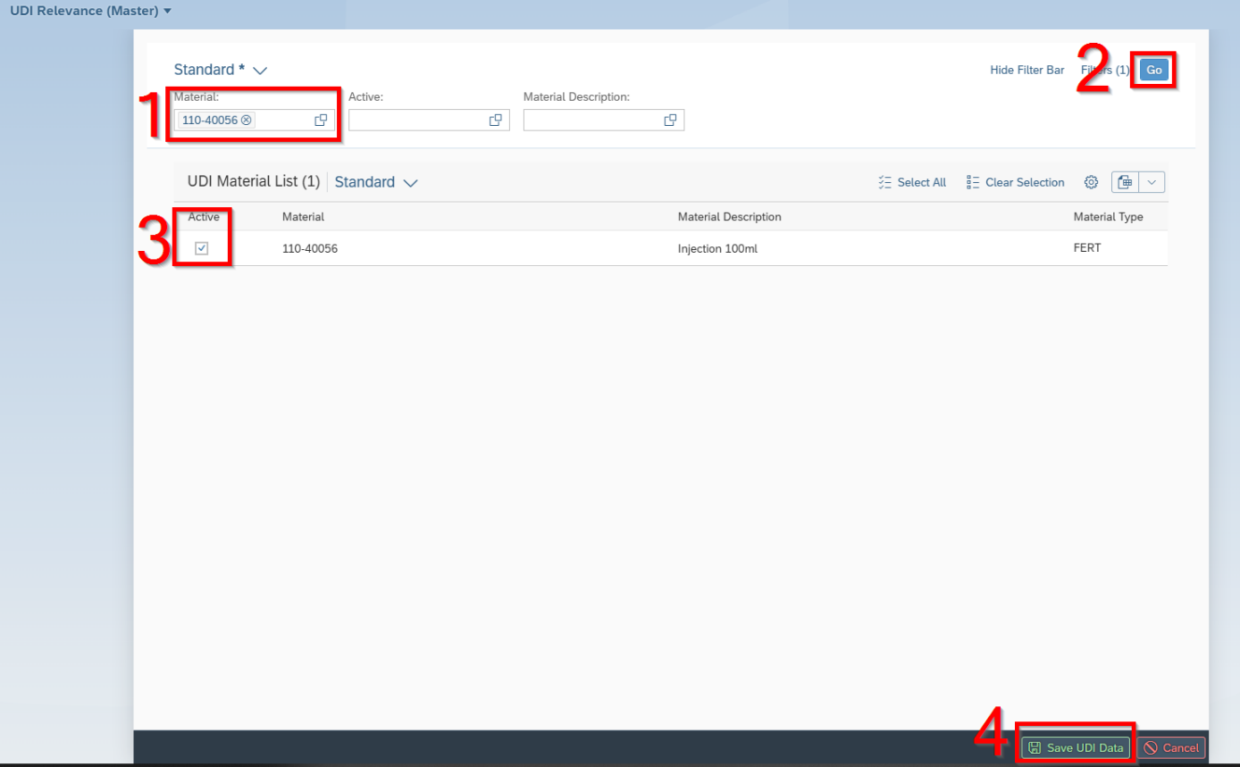

- Write material number in that field
- Click Go
- Click on Active
- Save UDI Date

Create New version of Master UDI

Once you've updated the UDI relevance status, the counter on the Fiori tile "Set UDI Relevance" will automatically reflect the count of all products that have been activated.

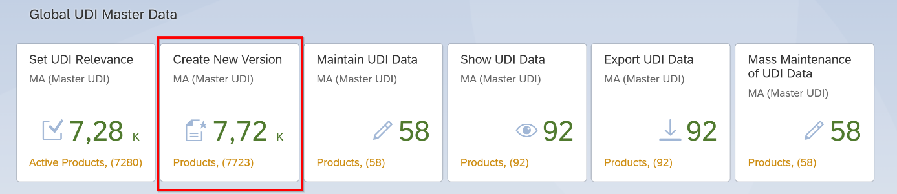
- Access the "Create New Version" Application.

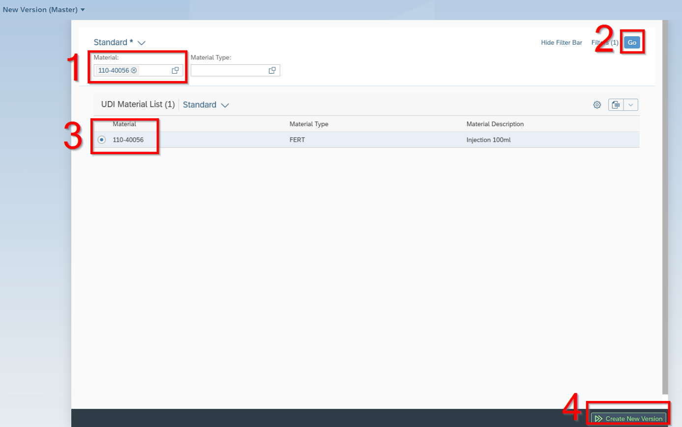
- Write material number in that field
- Click Go
- Select material
- Click on the "Create new version" button to proceed.

- A new screen opens:
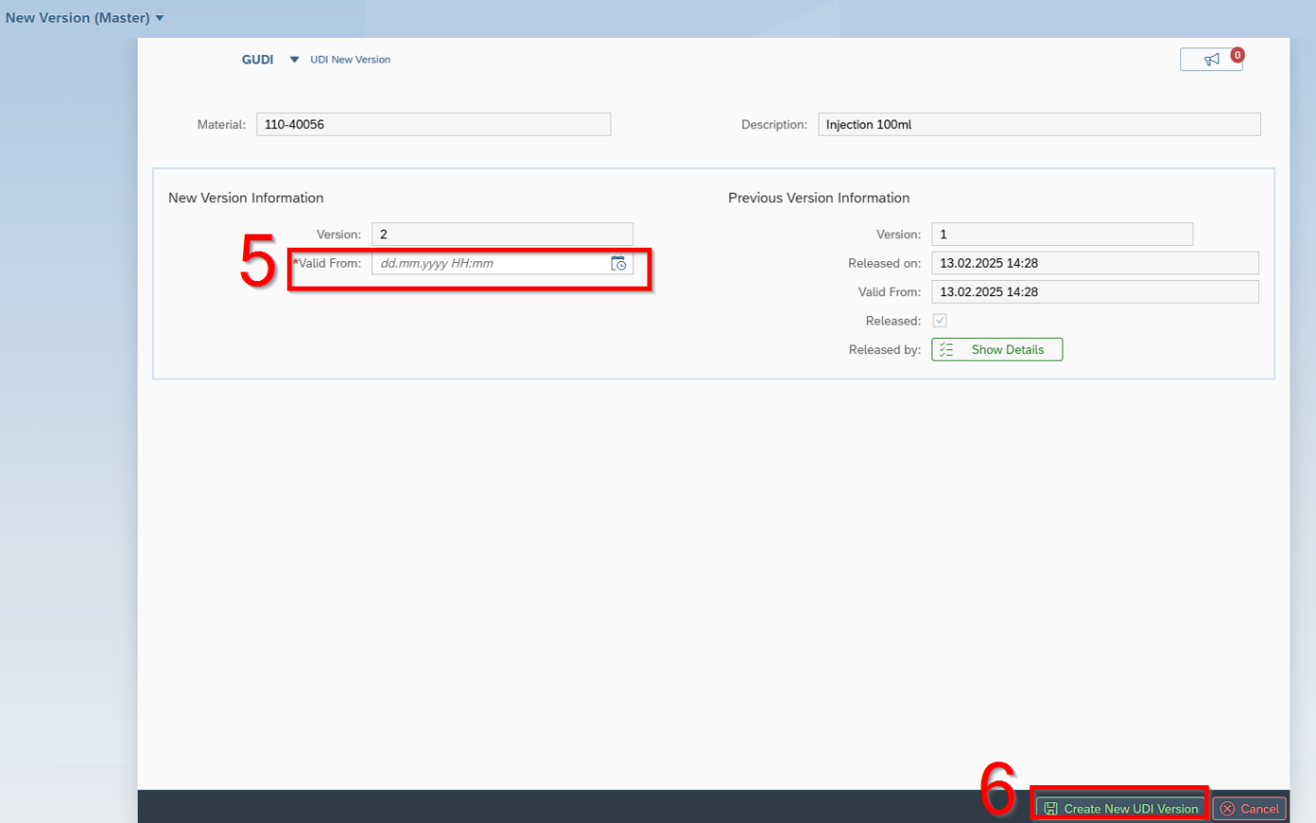
- Enter the "Valid from" date as a date in the future.
- Click the "Create New Version" button to proceed.

Maintain Master UDI

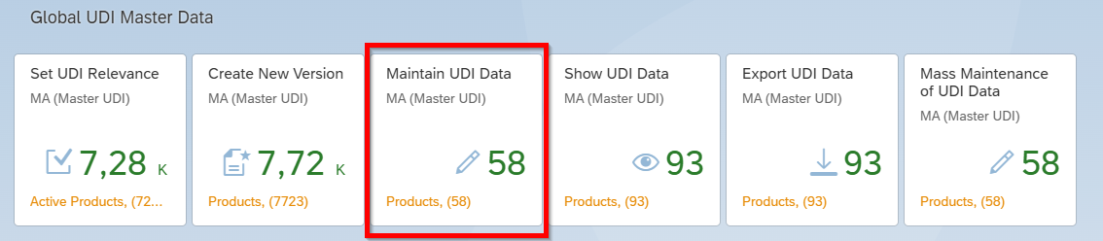
- Access the "Create New Version" Application.
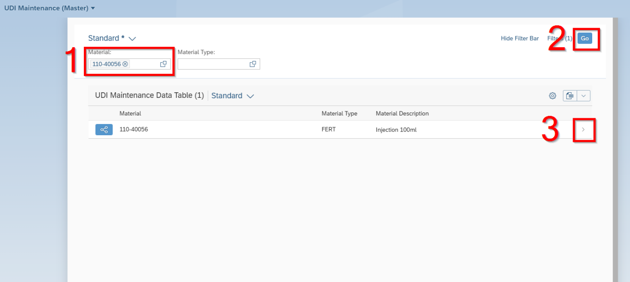
- Write material number in that field
- Click Go
- Select material

- A new screen opens:

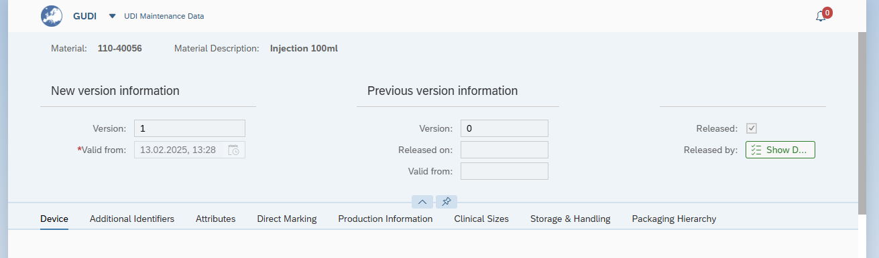

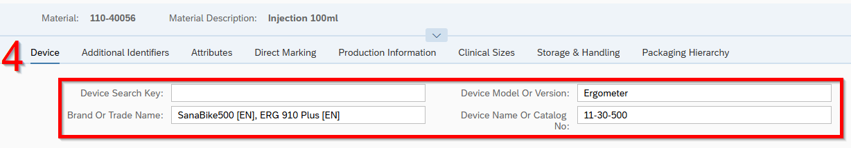
- Fill in:
- Device Search Key
- Brand or Trade Name
- Device Model or Version
- Device Name or Catalog No
At least Device Name or Device Model is mandatory!
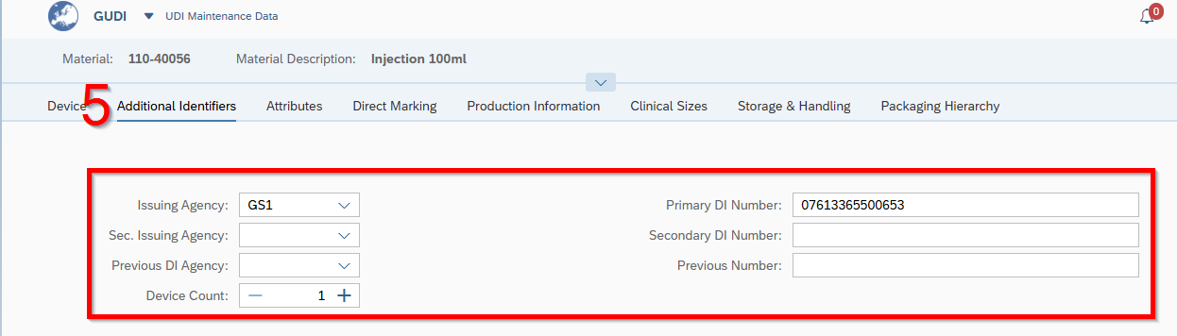
- Choose / Fill in:
- Issuing Agency (mandatory!)
- Primary DI Number (mandatory!)
- Sec. Issuing Agency
- Secondary DI Number
- Previous DI Agency
- Previous Number
- Device Count

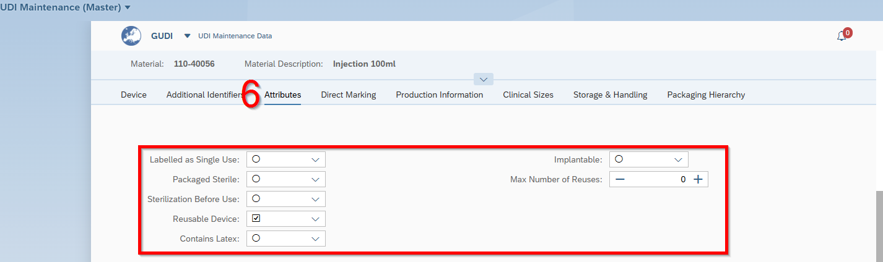
- Except the field Max. Number of Reuses, all fields are dropdown list, in which you need to set yes or no. All these fields are mandatory:
- Label as Single use
- Packaged Sterile
- Sterilization before use
- Reuseable Device
- Contains Latex
- Implantable
- Max. Number of Reuses

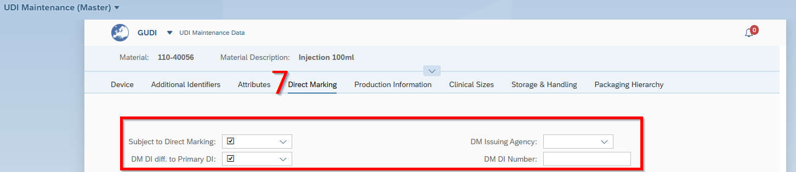
- Except the field DM DI Number, all fields are dropdown list, in which you need to set yes or no. All these fields are mandatory:
- Subject to Direct Marketing
- DM DI diff. to Primary DI
(If you select here yes, when you need to fill in DM Issuing Agency and DM DI Number too.)
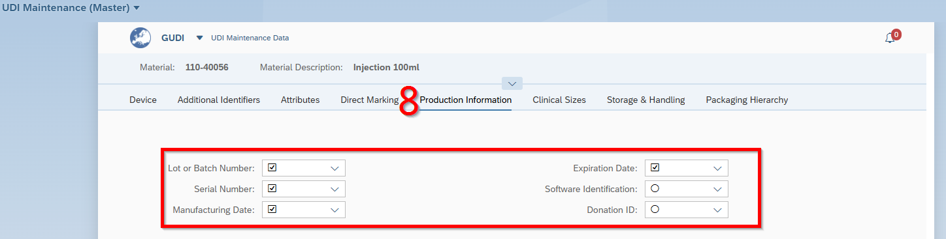

- All fields are dropdown list, in which you need to set yes or no. All these fields are mandatory:
- Lot or Batch Number
- Serial Number
- Manufacturing Date
- Expiration Date
- Software Identification
- Donation ID
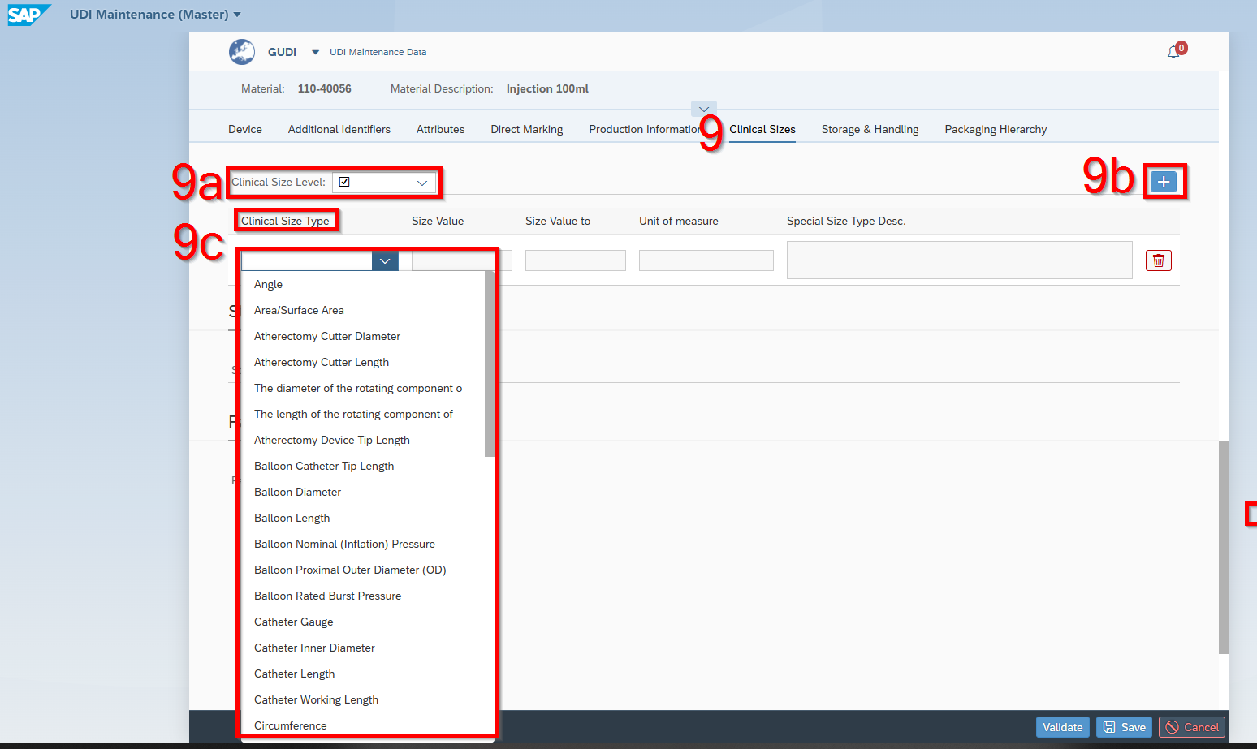
- Clinical Sizes
9a Clinical size level is a dropdown list (Yes or No). If you select yes, when you need to continue with 9b in clicking on the + button.
Following this You need to choose from the dropdown list the 9c Clinical Size Type. Fill in the Size Value and Size Value to and choose the Unit of measure from the dropdown list.
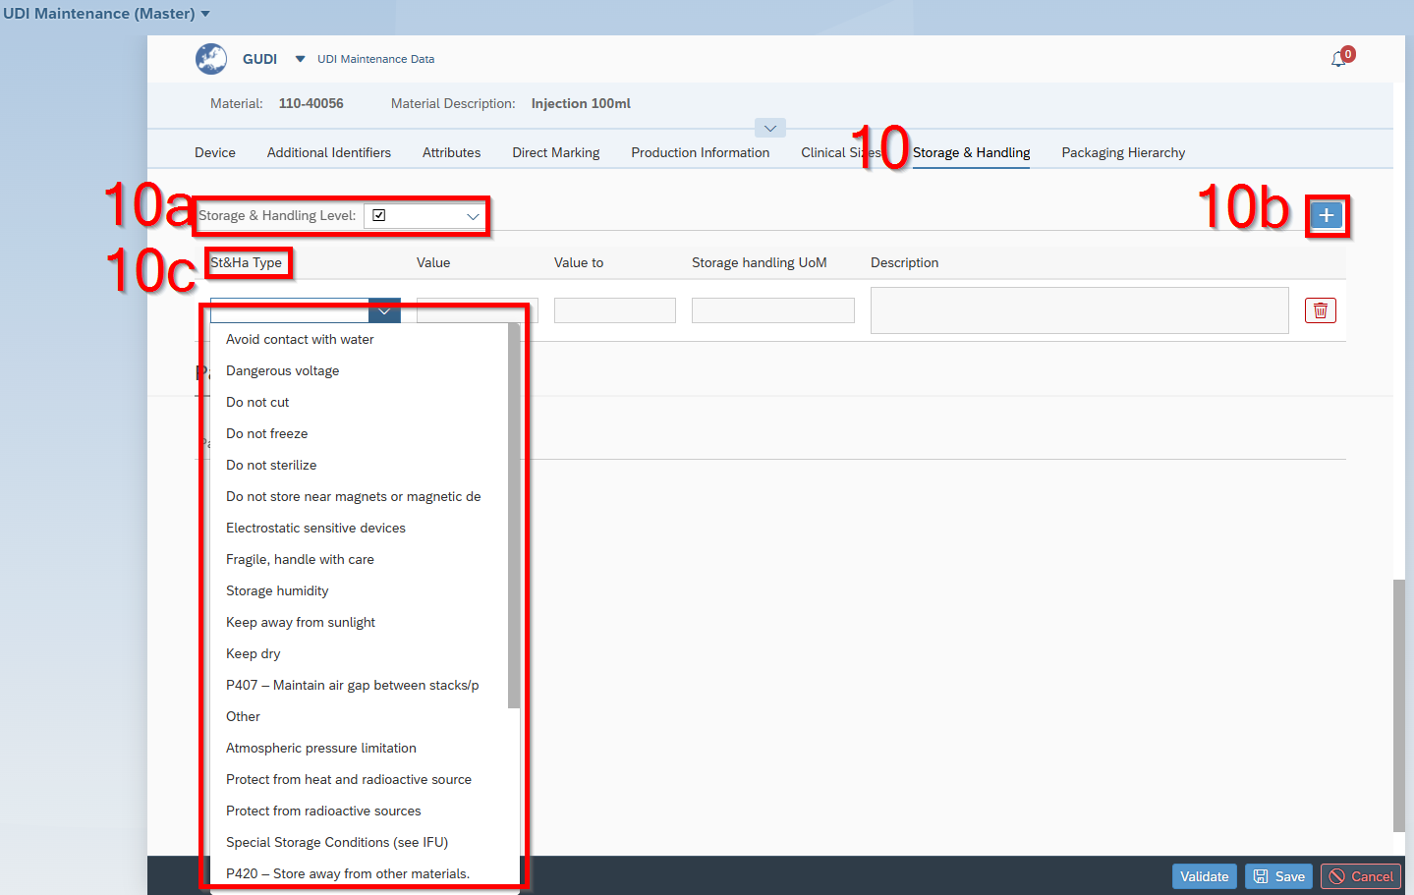

- Storage & Handling
10a “Storage & Handling Level” is a dropdown list (Yes or No). If you select yes, when you need to continue with 10b in clicking on the “+” button.
Following this you need to choose from the dropdown list the 10c “St&Ha Type”. Fill in the ”Value” and “Value to” and “Storage handling UoM”.

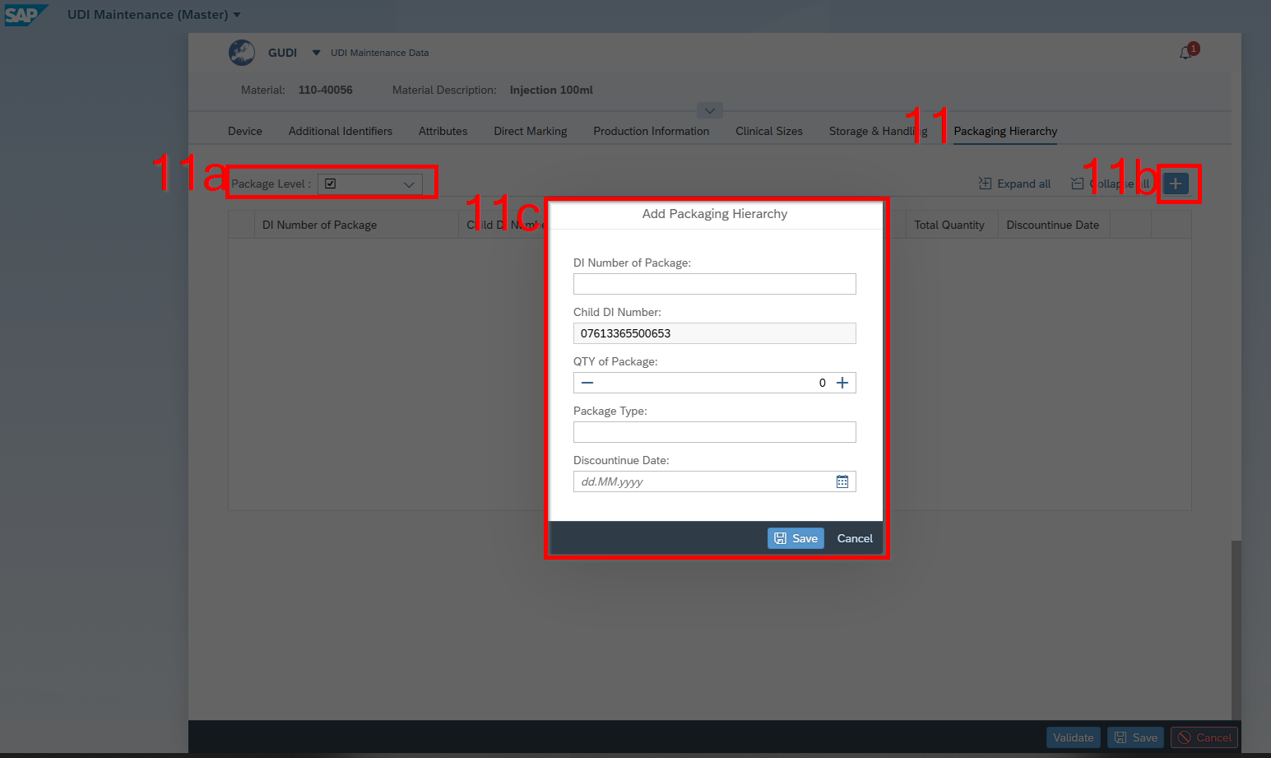

- Packaging Hierarchy
a “Package Level” is a dropdown list (Yes or No). If you select yes, when you need to continue with
b in clicking on the “+” button.
Following this a window pops up
c Please fill in all values and click on save.

Error messages

To maintain the accuracy of the information you provide; our software includes a data validation check feature.
- You can view the validation results by clicking on the “Bell” icon. (1)
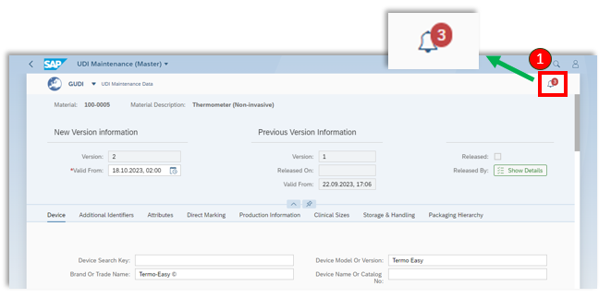

- The red number displayed on the bell icon indicates the number of failed validation checks.
- Clicking on the bell icon will display all validation messages. (2)

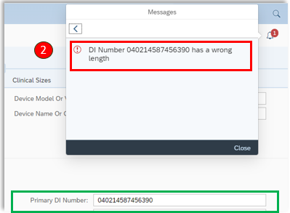
In the following example, the entered GS1 number has an incorrect length

Start release Workflow of Master UDI

Once you have ensured the accuracy of your data and resolved any validation errors, you can initiate the release workflow. This feature is accessible within the "Cross-Application-Services" plugin.

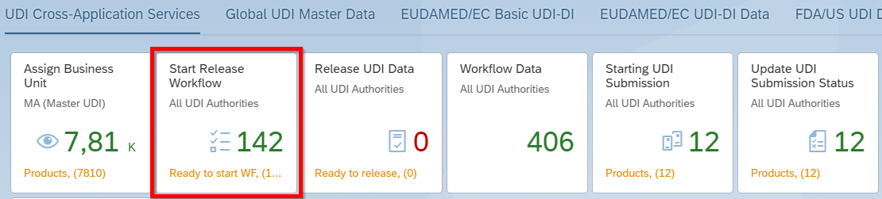
- Access the "Start Release Workflow" Application.

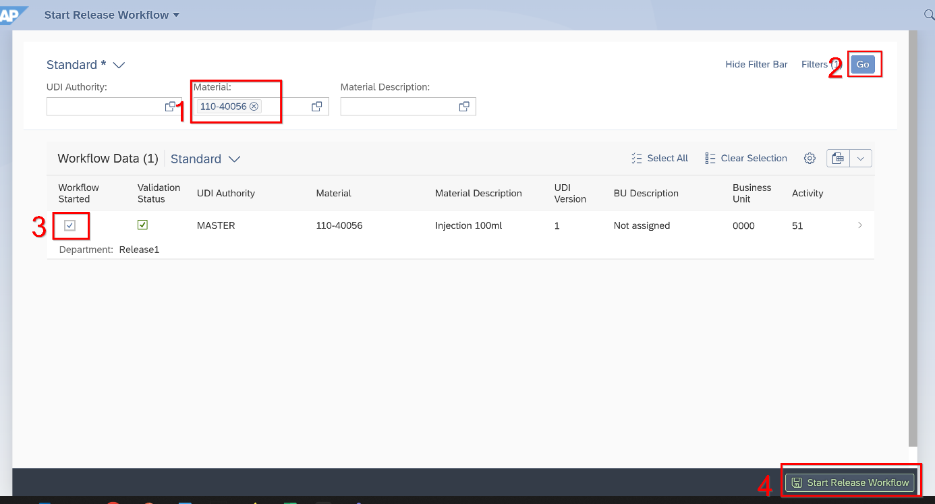

- Write material number in that field
- Click Go
- Click on Active
- Start Release Workflow

Release Master UDI Data

Once you have initiated the release workflow, the UDI data becomes locked, preventing any further modifications until the data are released or the release workflow is rejected.
The number of departments responsible for the release process may vary depending on the configuration of your SAP system. However, it is essential to have at least one department with at least one user assigned to facilitate the release process.
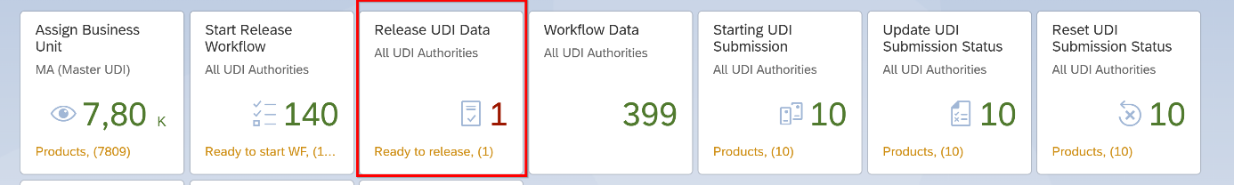
- Access the " Release UDI Data" Application.

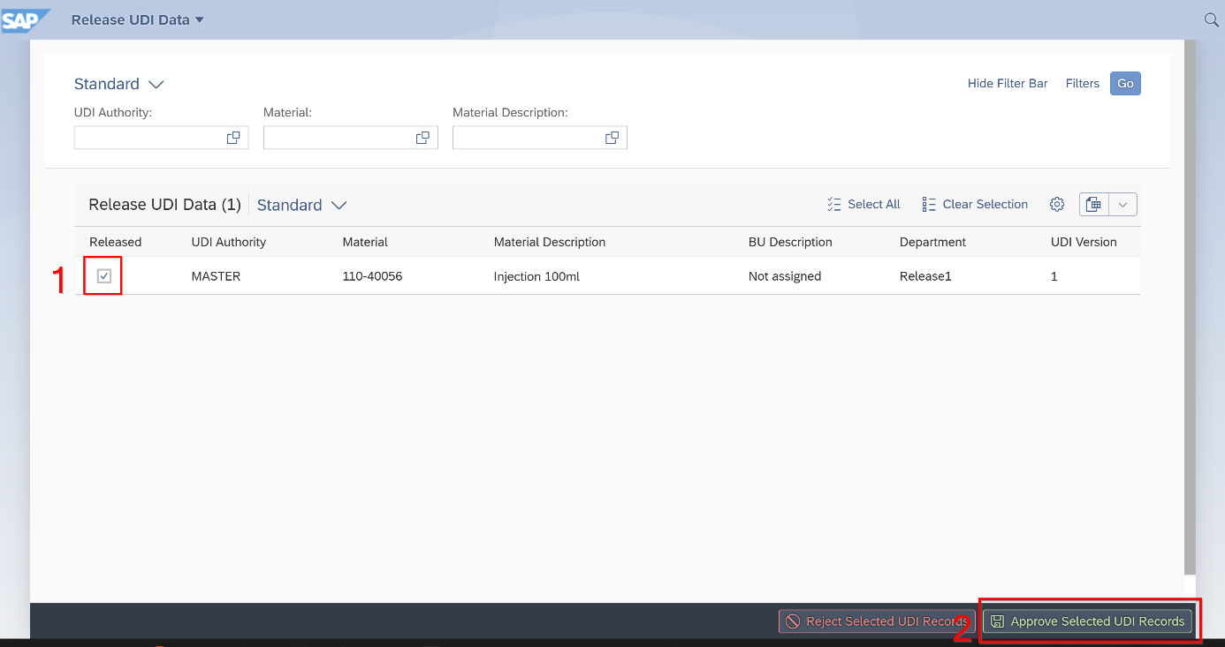

- Select released Material
- Click “Approve Selected UDI Records”

EUDAMED Basic UDI-DI

Create New Basic UDI-DI

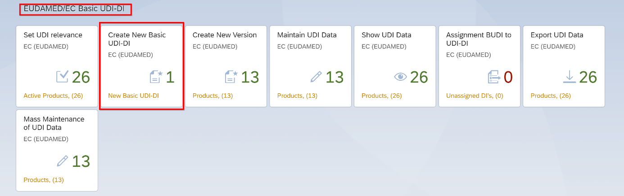
- Access the " Create New Basic UDI-DI" Application.

Valid from

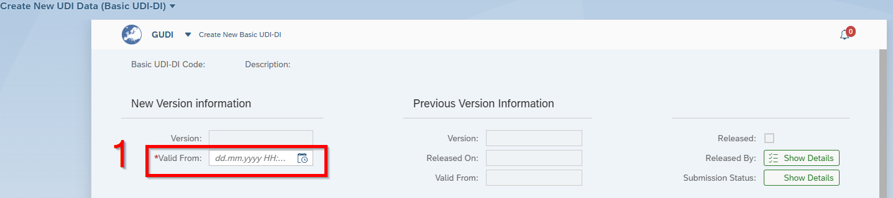
- Fill in “Valid From” date

Device

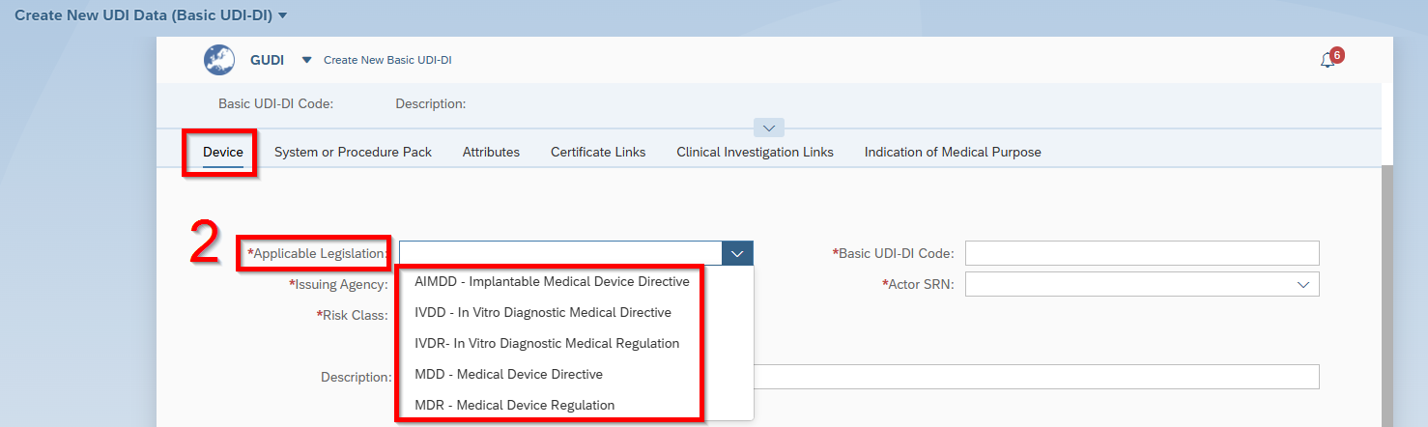
- Choose “Applicable Legislation”

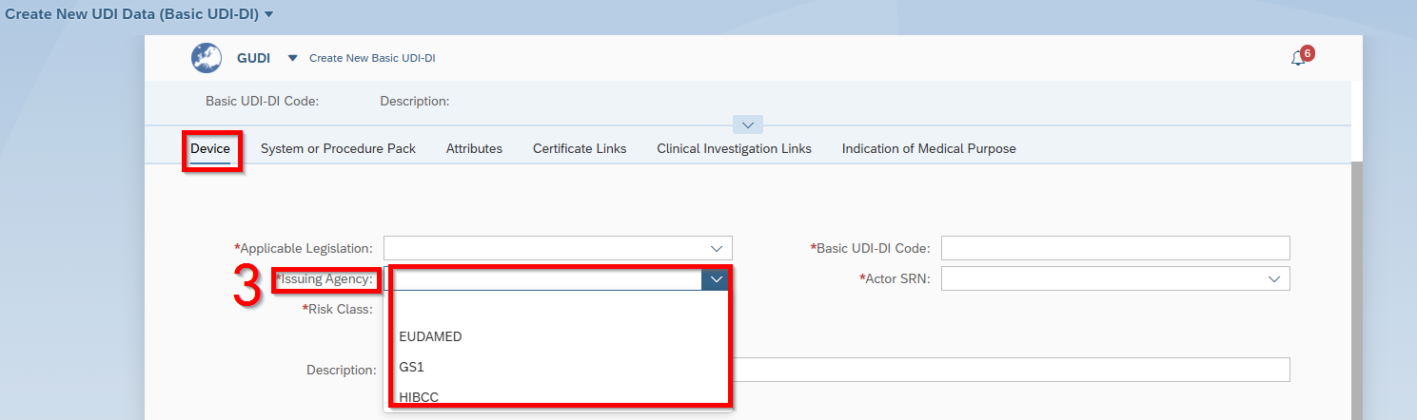
- Choose “Issuing Agency”

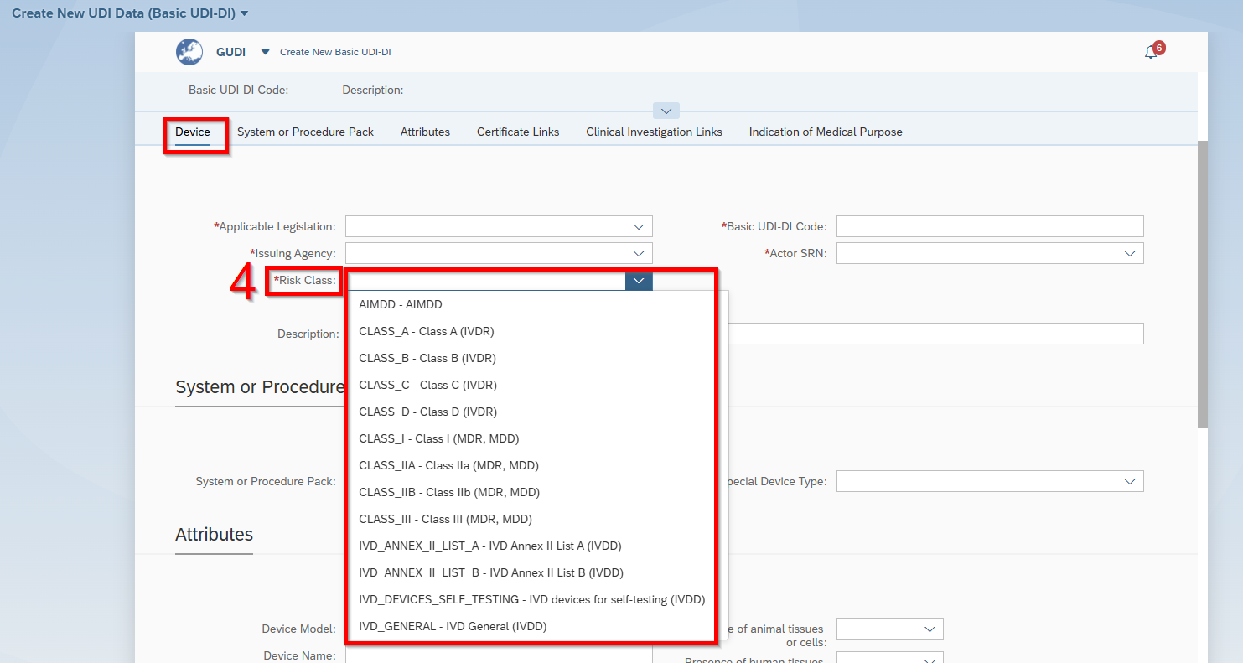
- Choose “Risk Class”

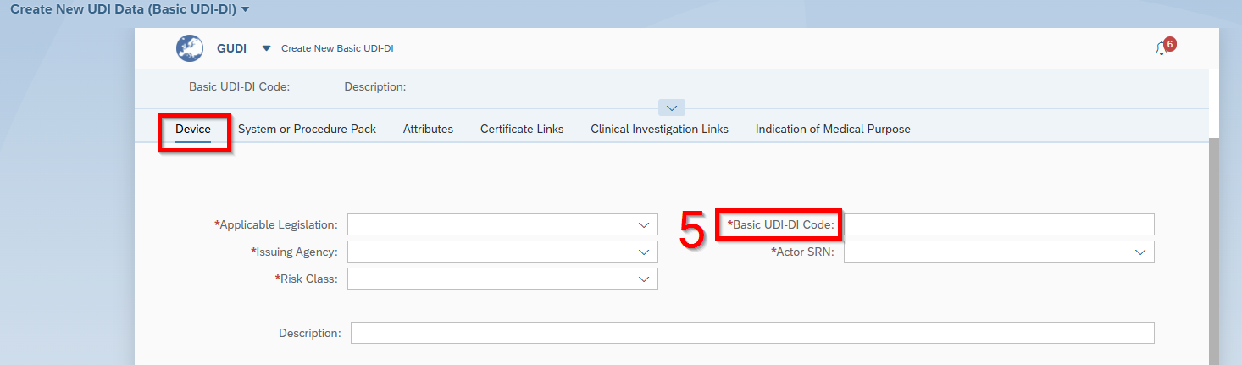
- Fill in “Basic UDI-DI Code”

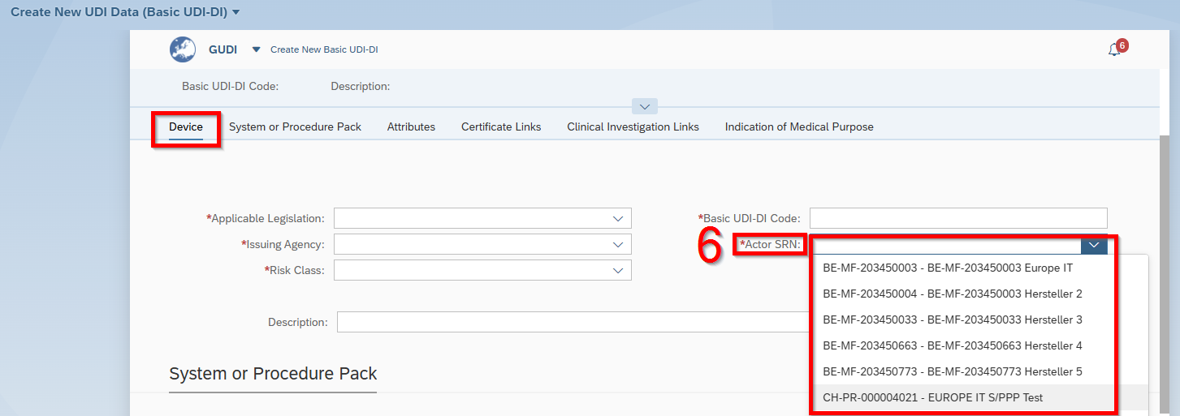
- Choose “Actor SRN”

System or Procedure Pack

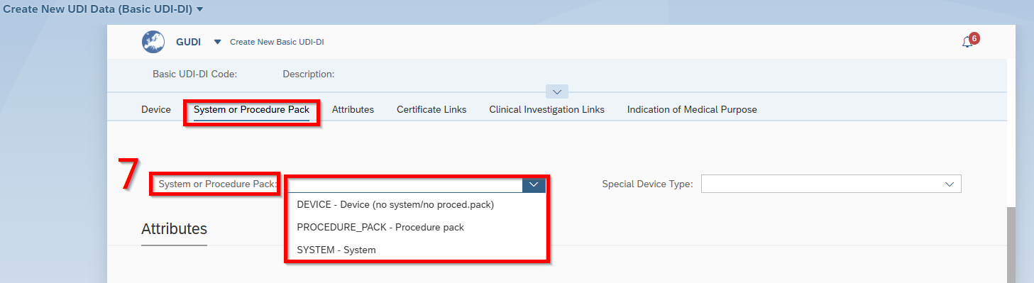
- Choose “System or Procedure Pack”

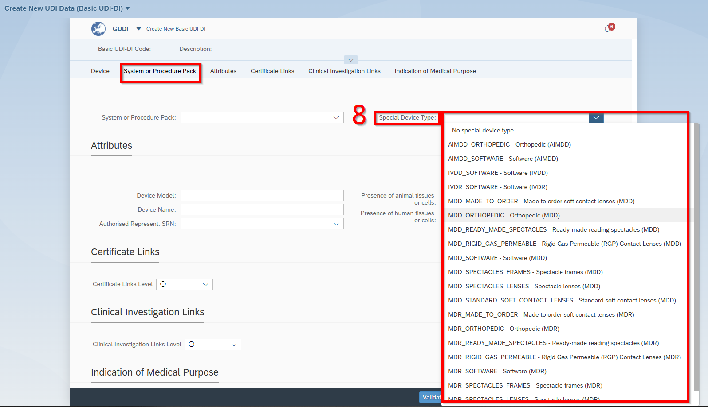

- Choose “Special Device Type”

Attributes

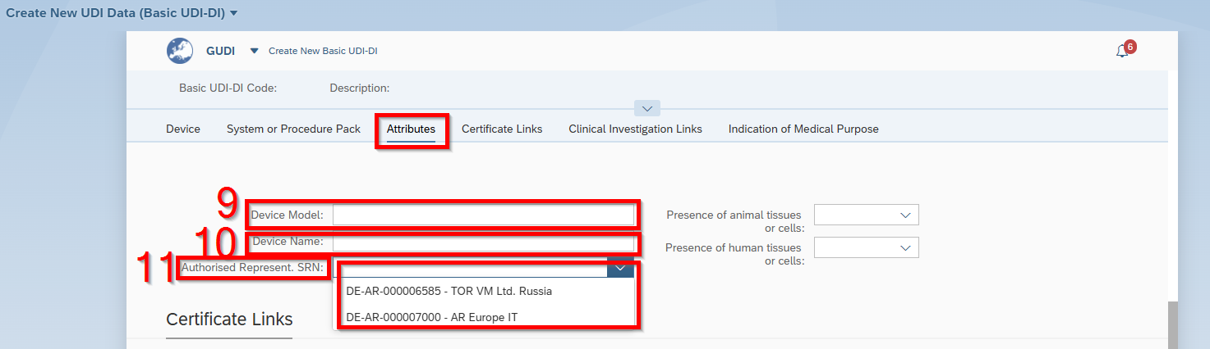
- Fill in “Device Model”
- Fill in “Device Name”
- Choose “Authorized Represent, SRN”

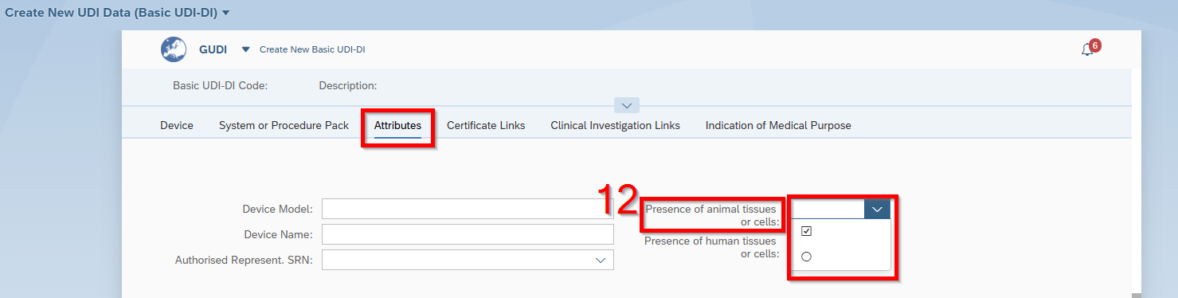
- Choose “Presence of animal tissues or cell” with yes or no.

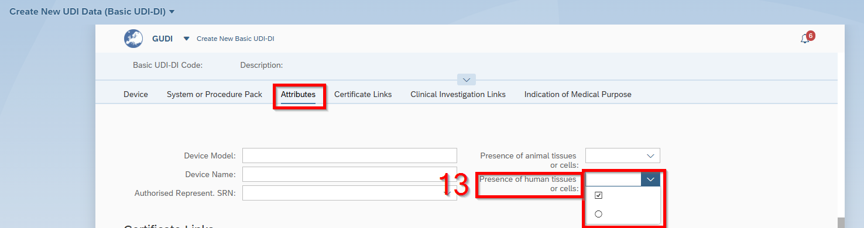
- Choose “Presence of human tissues or cell” with yes or no.

Certificate Links

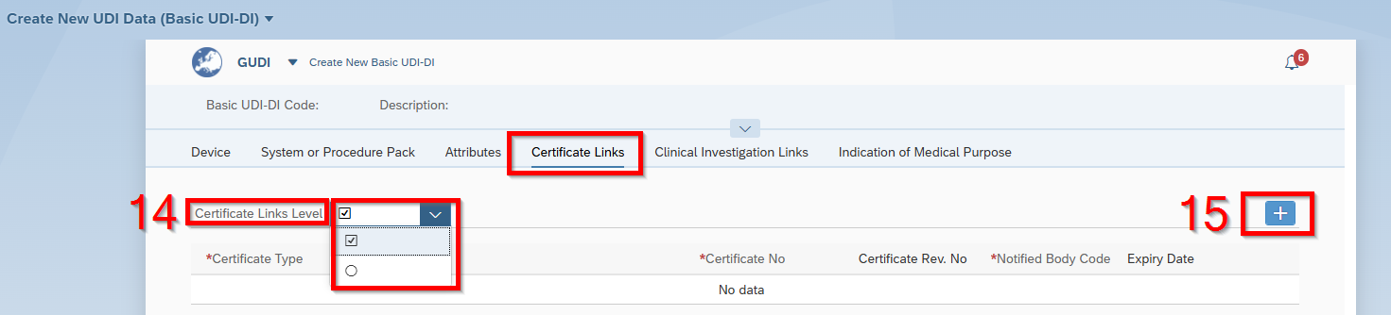
- Choose “Certificate Links Level” with yes or no.
- If under 14. was clicked on yes, than click on the “+” button

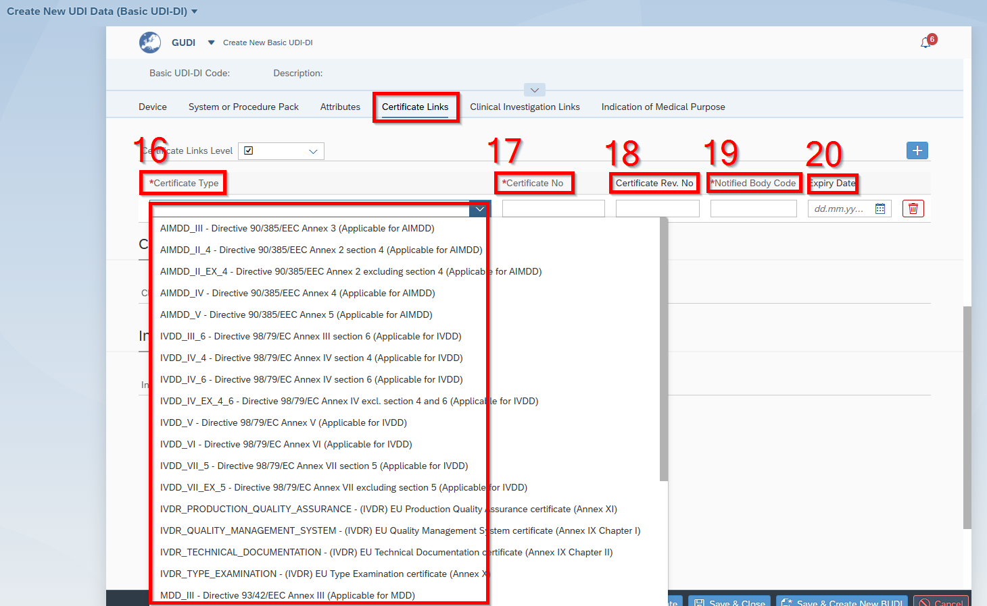
- Choose “Certificate Type”.
- Fill in “Certificate No.”
- Fill in ”Certificate Rev. No”
- Fill in “Notified Body Code”
- Fill in “Expiry Date”

Clinical Investigation Links

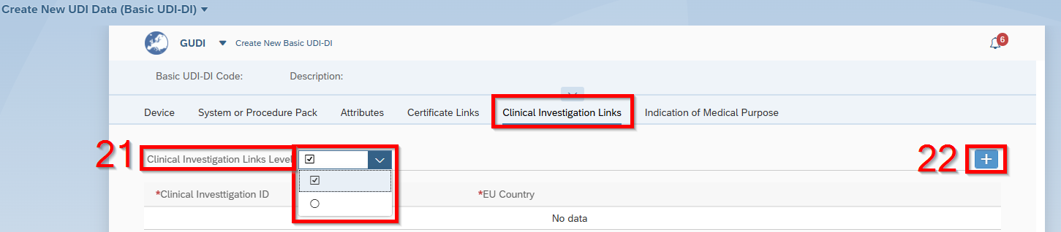
- Choose “Clinical Investigation Links Level” with yes or no.
- If under 21. was clicked on yes, than click on the “+” button

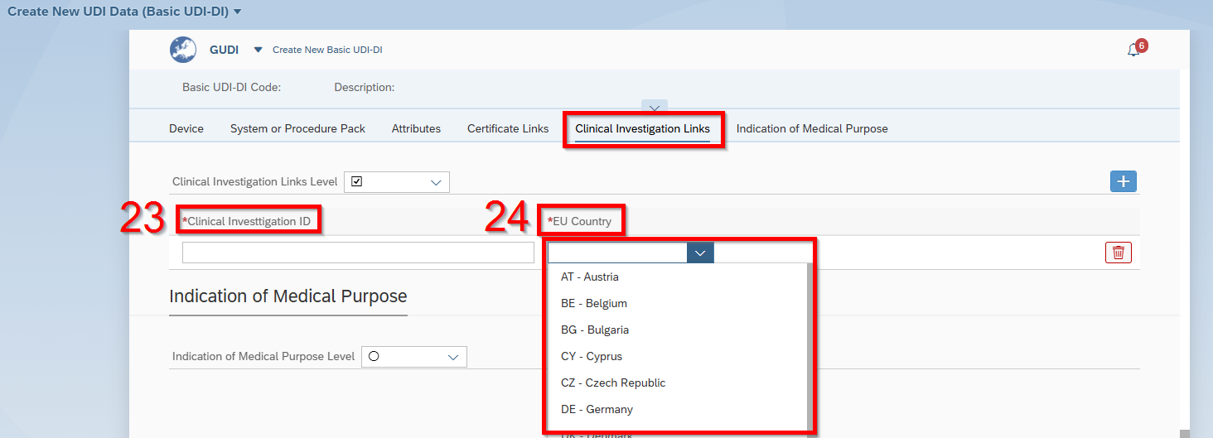
- Fill in “Clinical Investigation ID”
- Choose “EU Country”

Indication of Medical Purpose

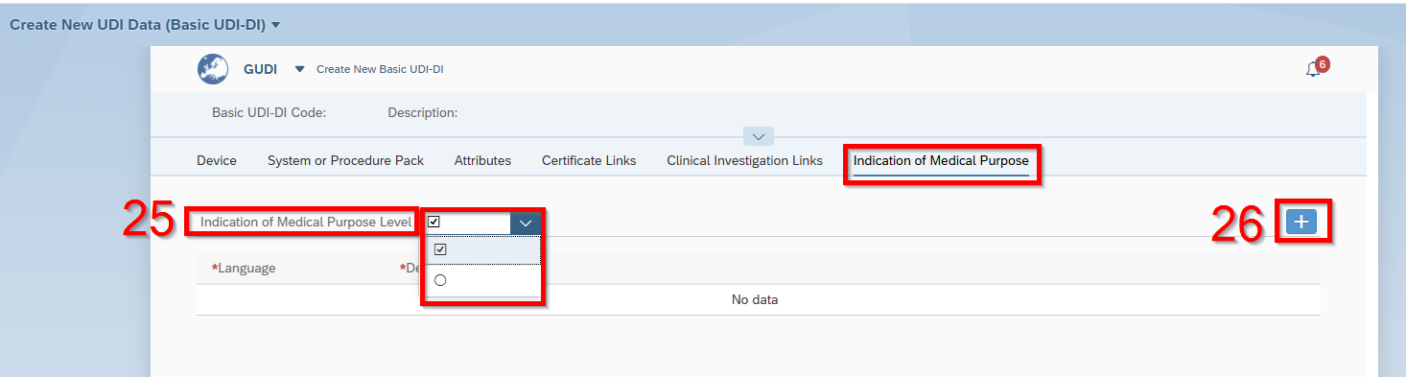
- Choose “Indication of Medical Pumps Level” with yes or no.
- If under 24. was clicked on yes, than click on the “+” button

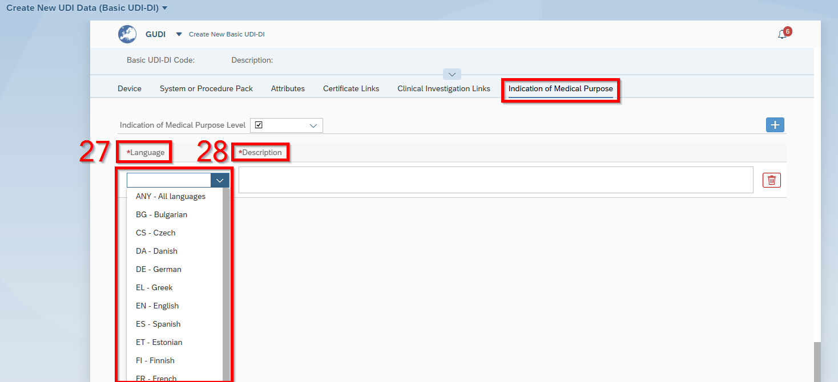
- Choose “Language”
- Fill in “Description”

Validation

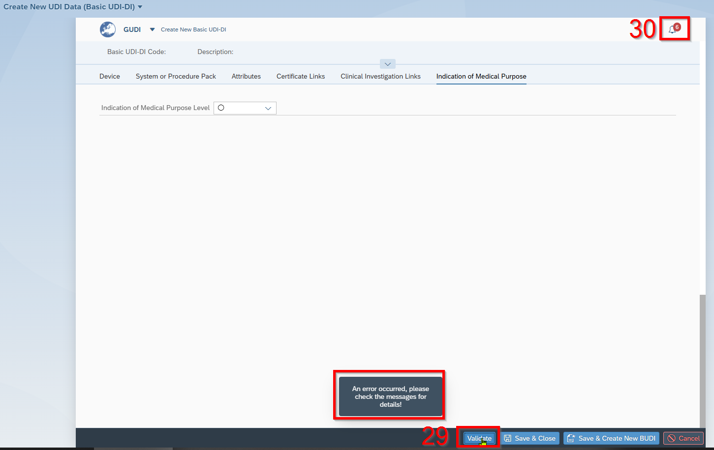
- Click on “Vaidate”.
- Click on the bell

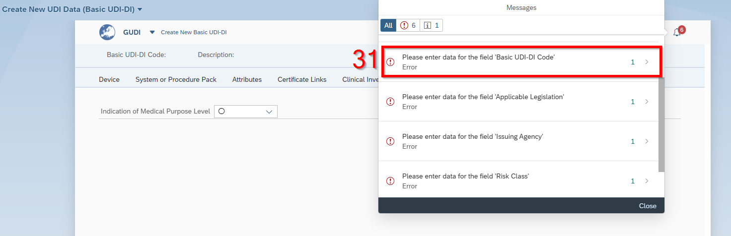
- Check the mistake

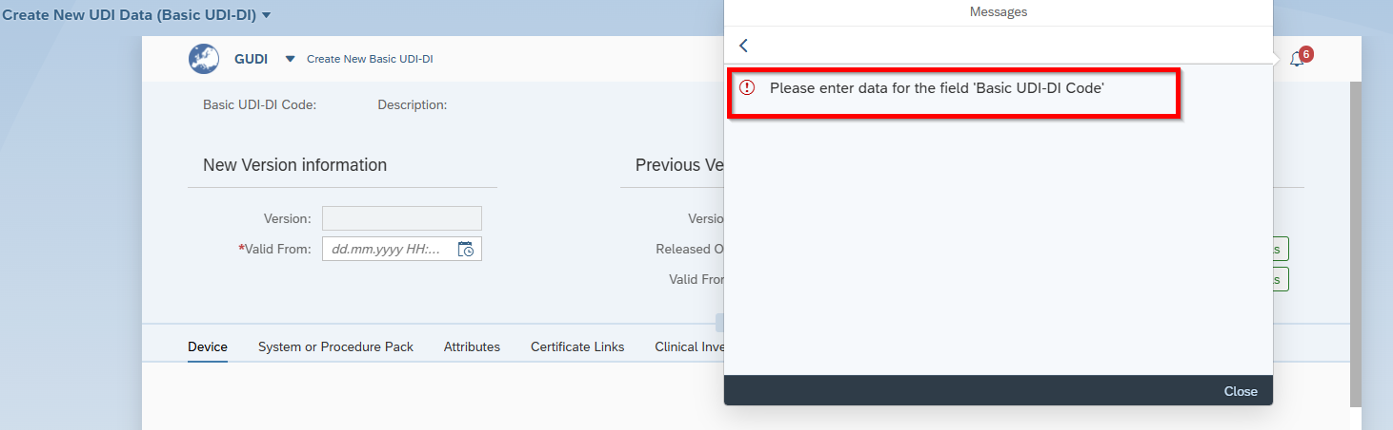

Save & Close

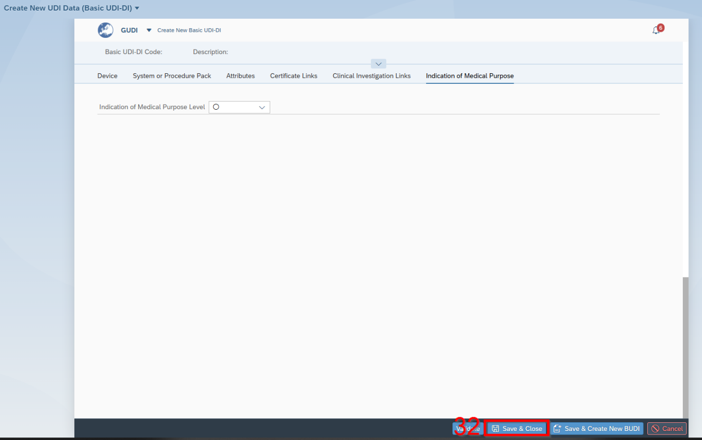
- Click on “Sava & Close”

Start Release Workflow of Basis UDI-DI

- Access the " Start Release Workflow" Application.

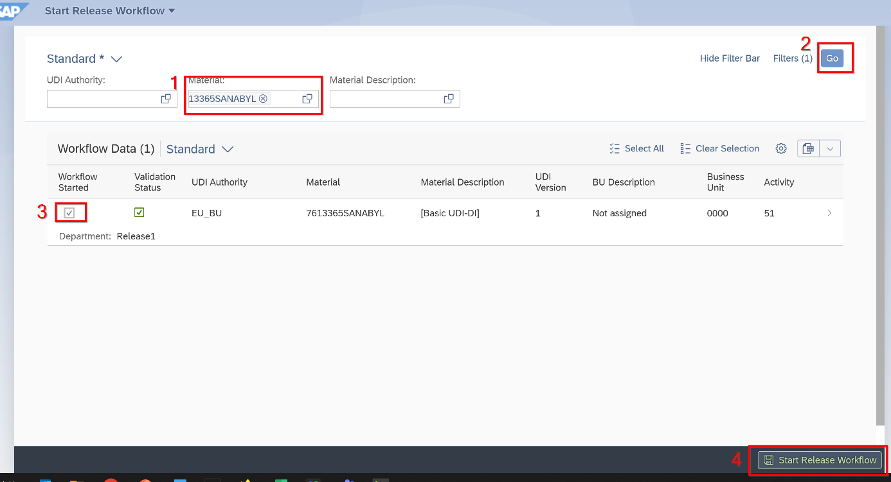
- Write or search the Basic UDI-DI number
- Click on „Go“
- Select the Basic UDI-DI
- Click on „Save Releas Workflow“
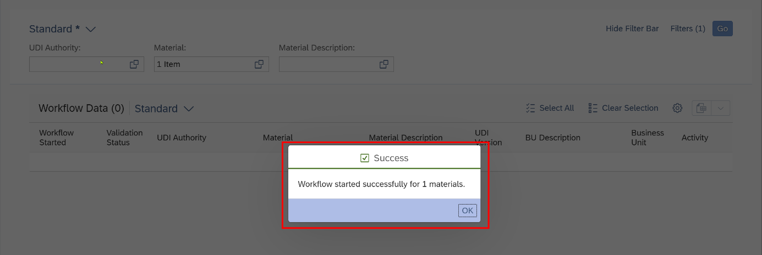

Release the Basic UDI-DI

- Access the " Release UDI Data" Application.

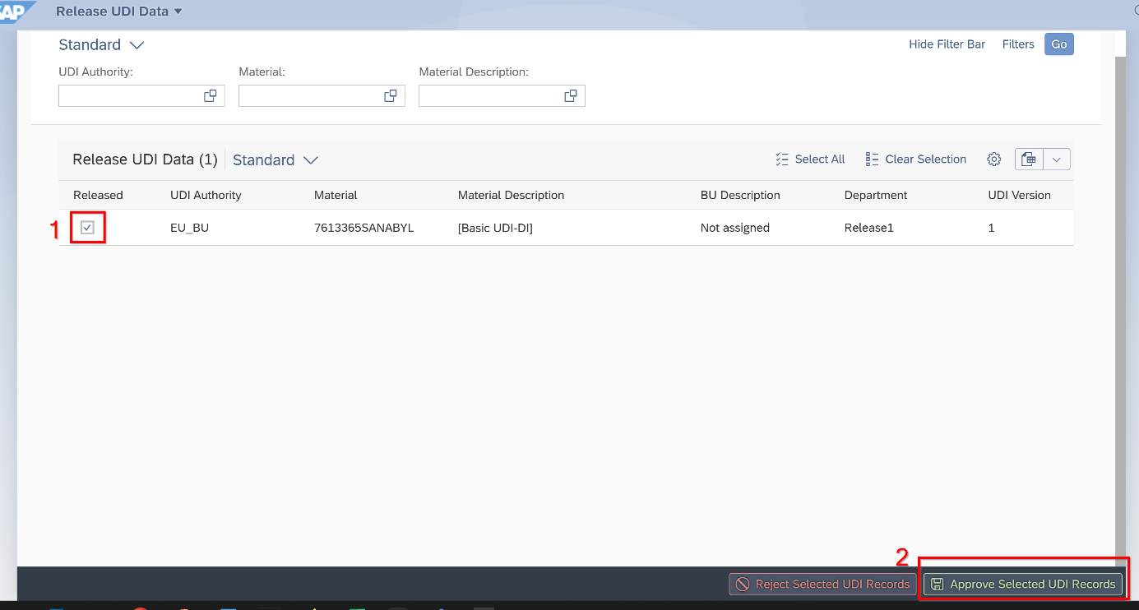
- Select the Basic UDI-DI
- Click on „Approve Selected UDI Records“

EUDAMED UDI-DI

Set UDI-DI Relevance

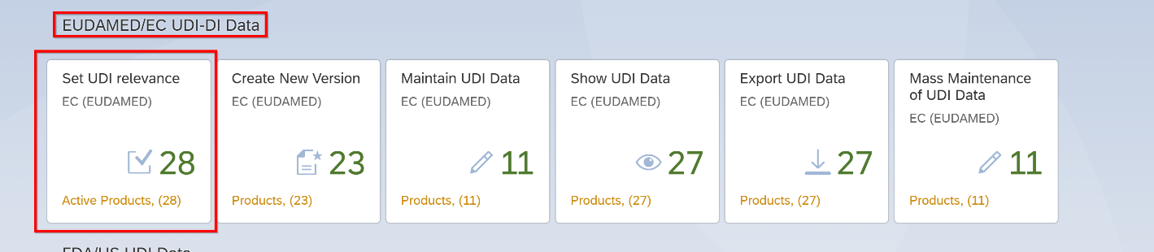
- Access the " Set UDI relevance" Application.

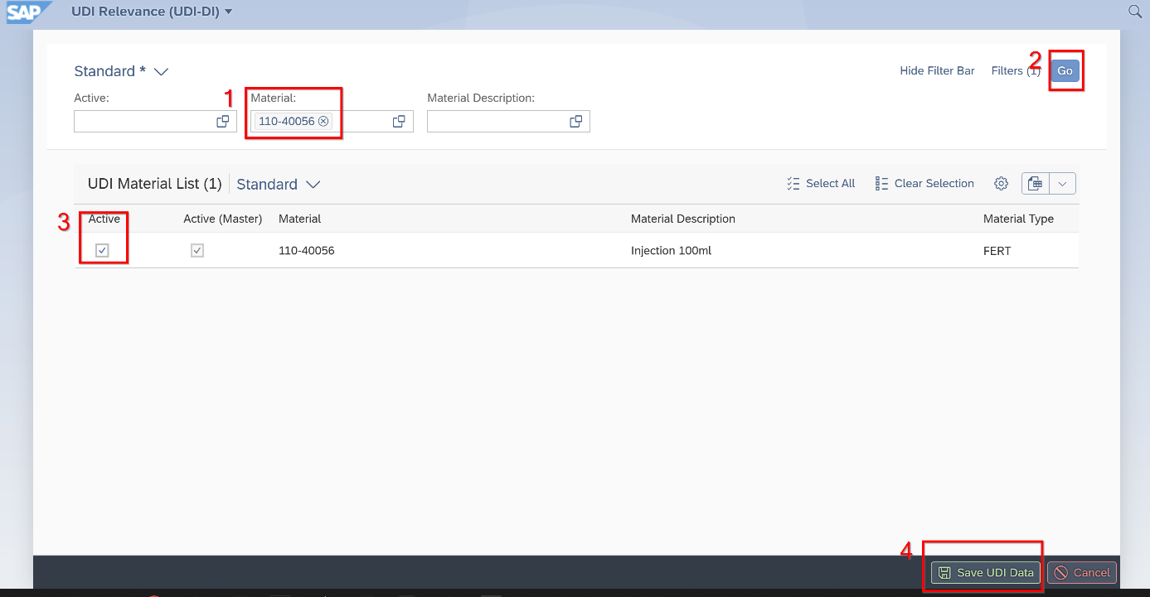
- Write material number in that field
- Click Go
- Click on Active
- Save UDI Date

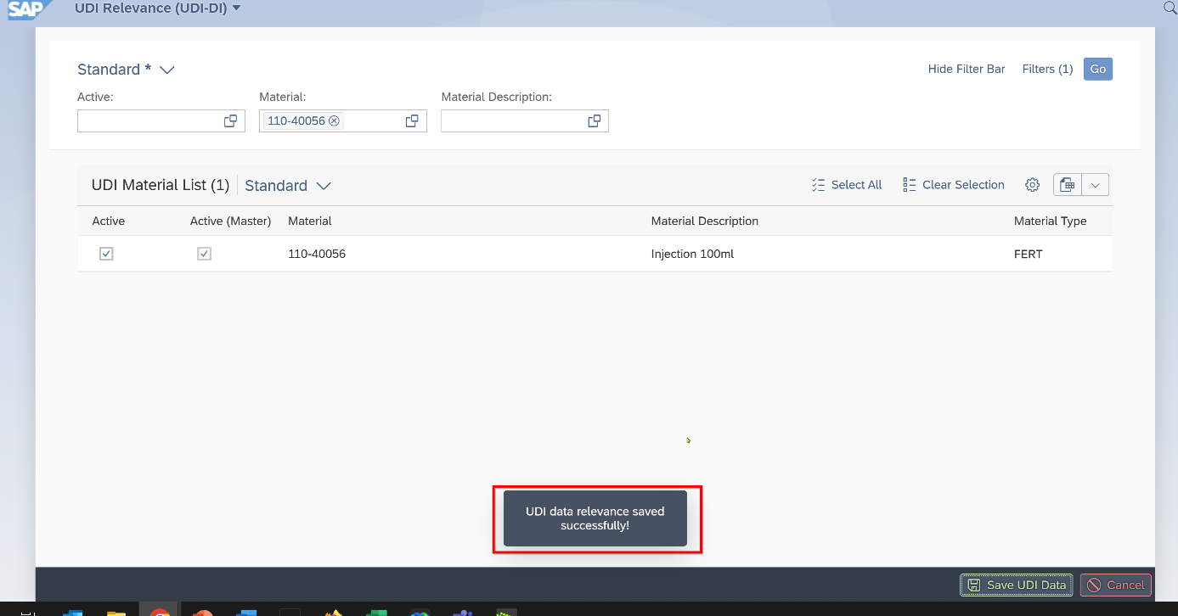

Create New Version of UDI-DI

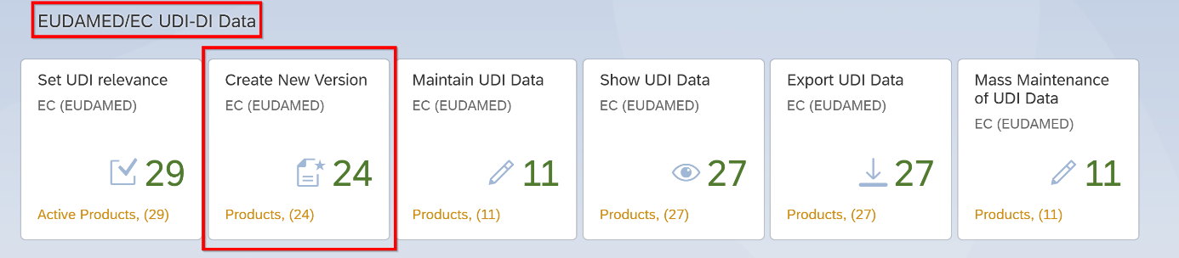
- Access the "Create New Version” of UDI-DI Application.

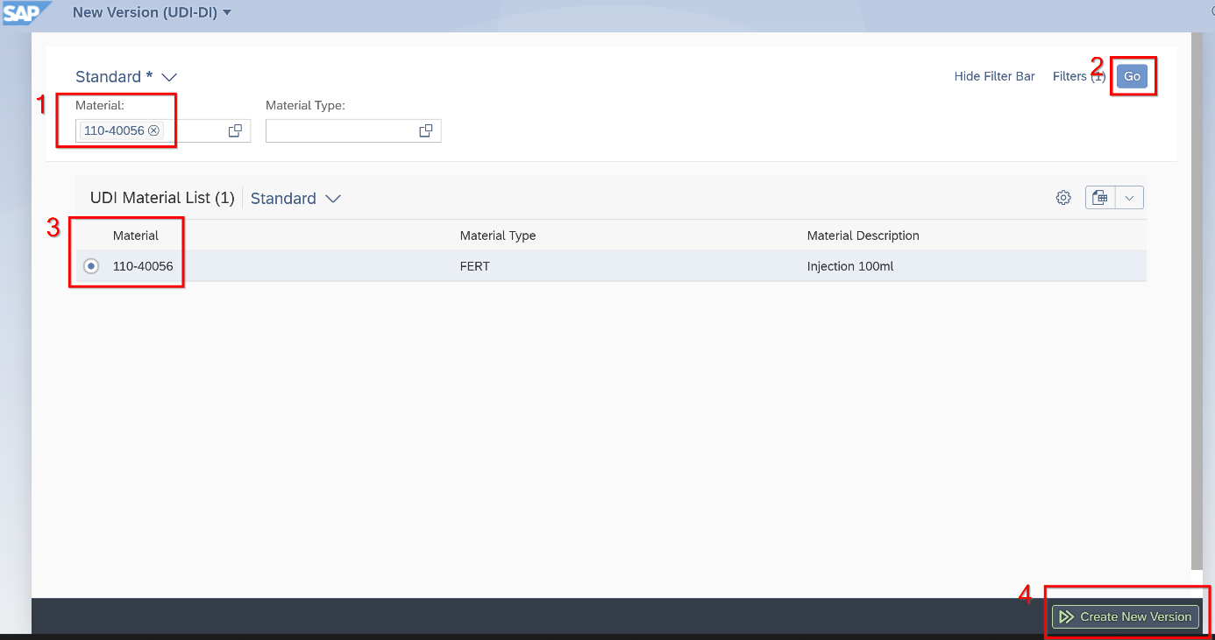
- Write material number in that field
- Click “Go”
- Click on Active
- Click “Create New Version”

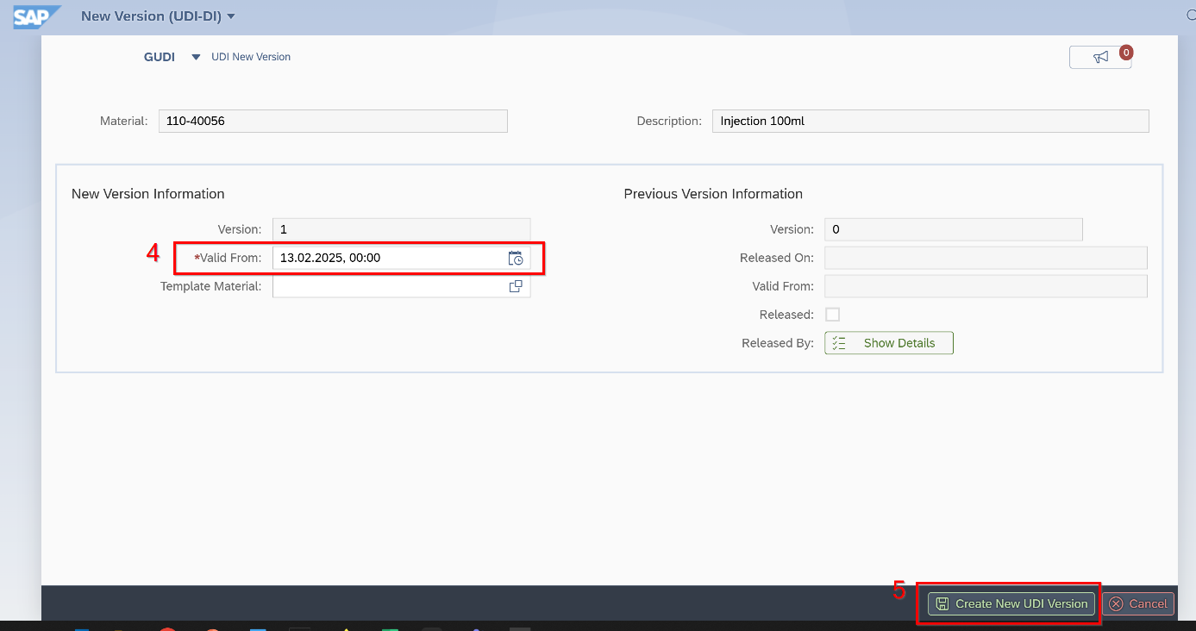
- Fill in “Valid From” date and click on “Create New UDI Version”

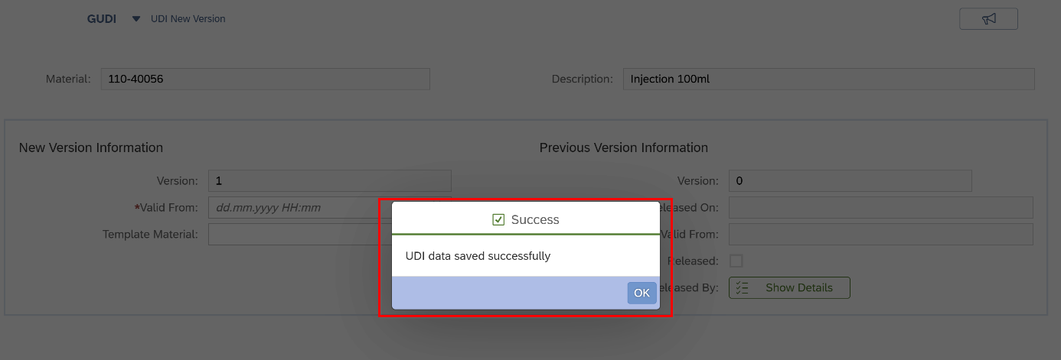

Maintain UDI-DI

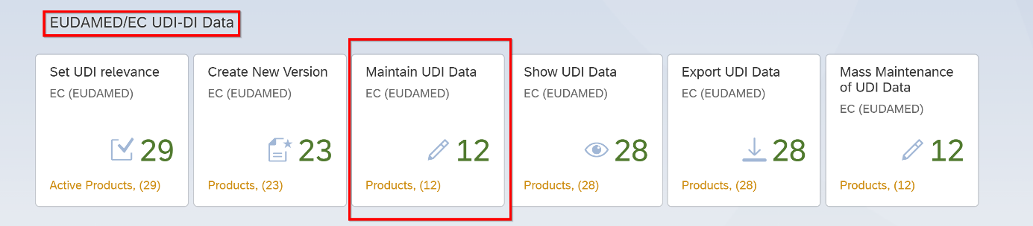
- Access the "Maintain UDI Data" Application.

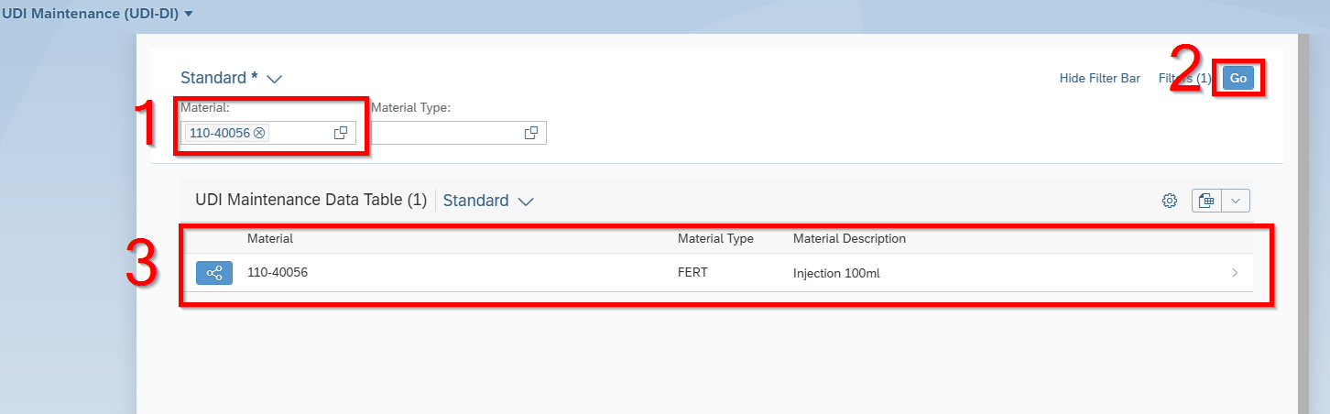
- Fill in the Material number
- Click on “Go”
- Select the Material

Device (Connect with Basic UDI)

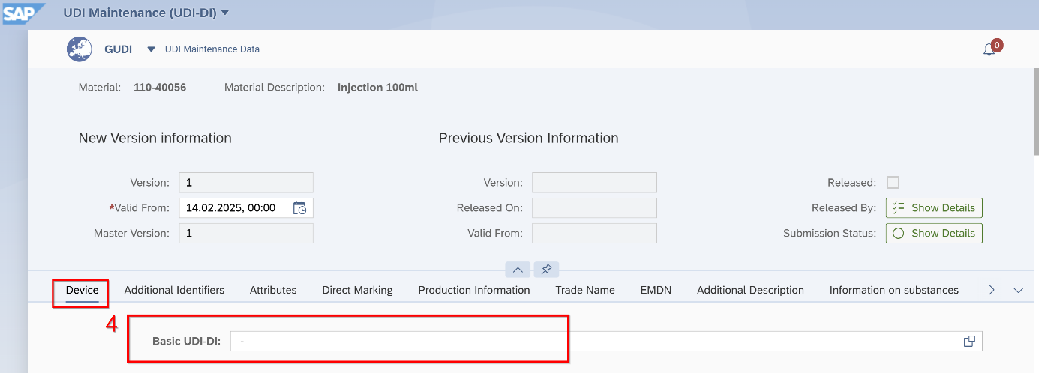
- Click in Basic UDI-DI

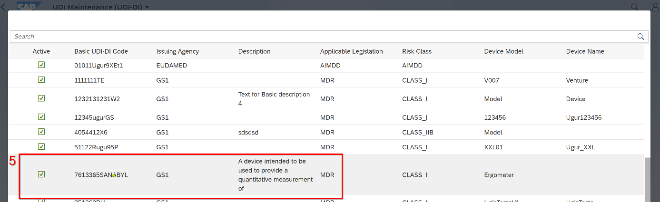
- Choose the Basic UDI-DI number which you want to connect to the material

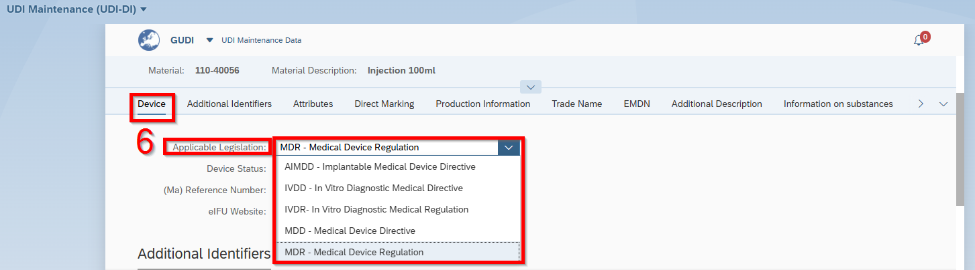
- Choose “Applicable Legistalion”

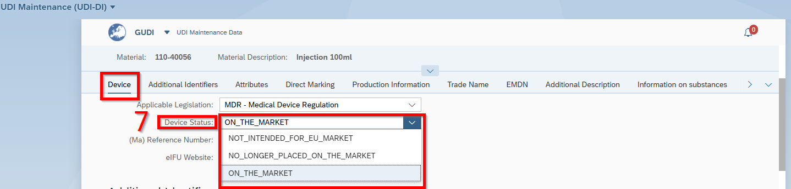
- Choose “Device Status”

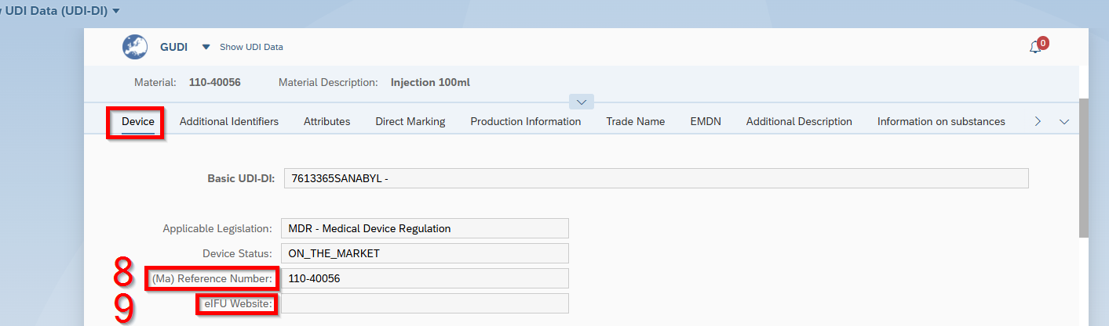
- “(Ma) Reference Number” comes from Master UDI. No actions here
- Fill in “eIFU Website”

Additional Identifiers

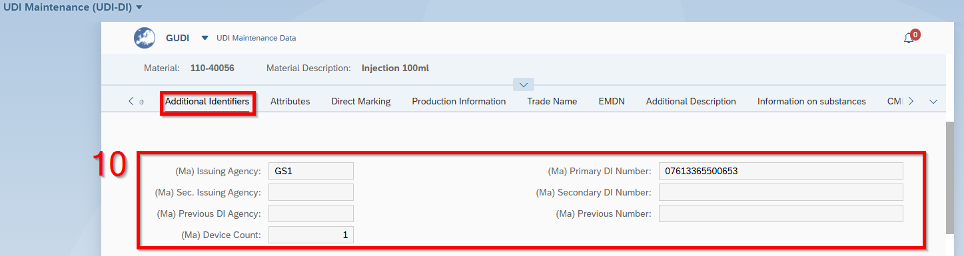
- These information come from the Master UDI. No actions

Attributes

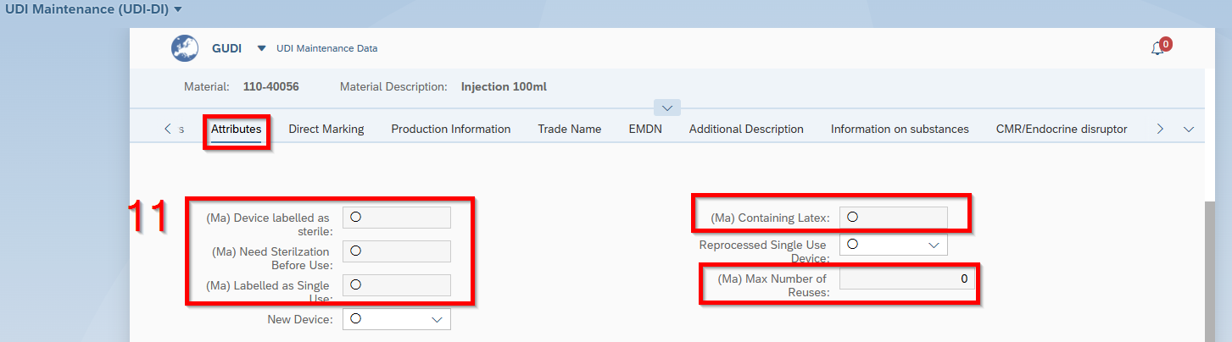
- These information comes from Master UDI. No actions.

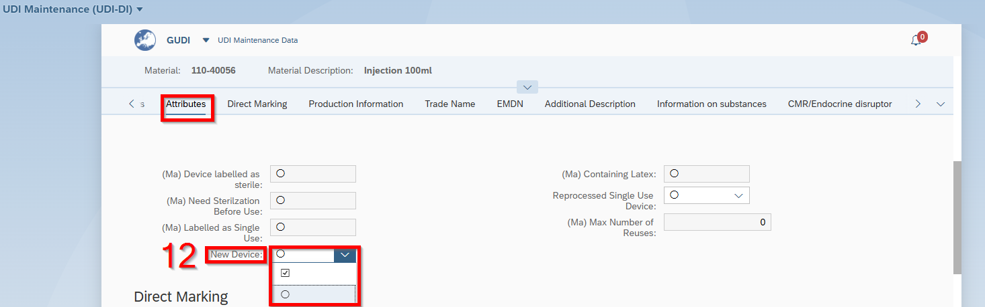
- If “New Device” necessary click yes or not.
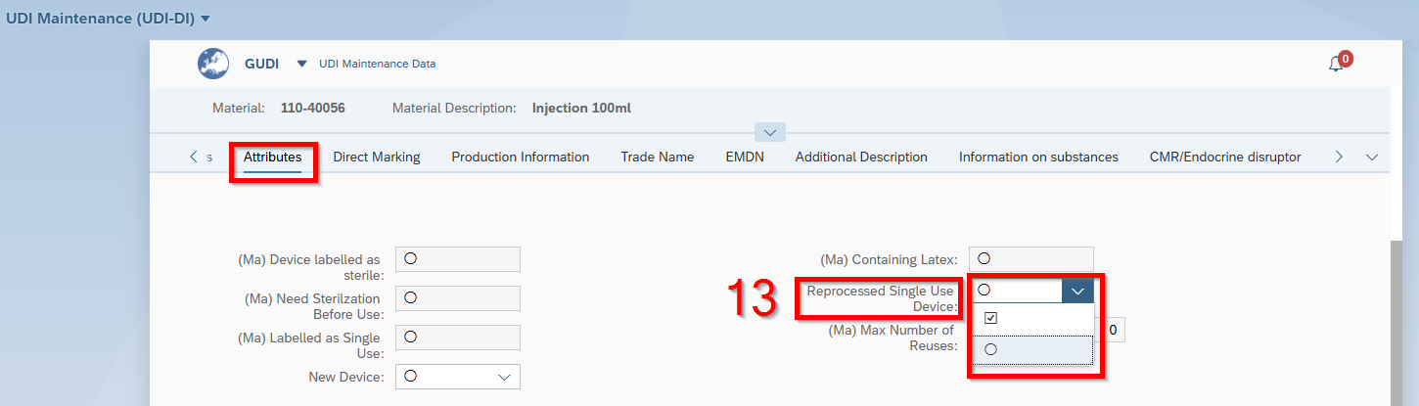
- Choose “Reprocess Single Single Use Device” yes or not.

Direct Marketing

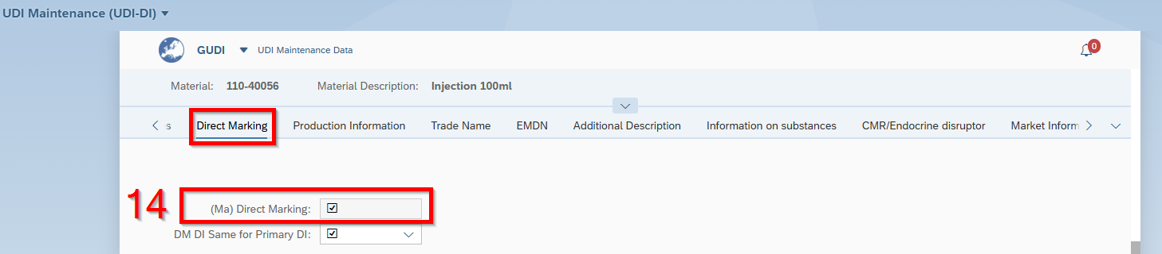
- Comes from Master UDI. No actions here.

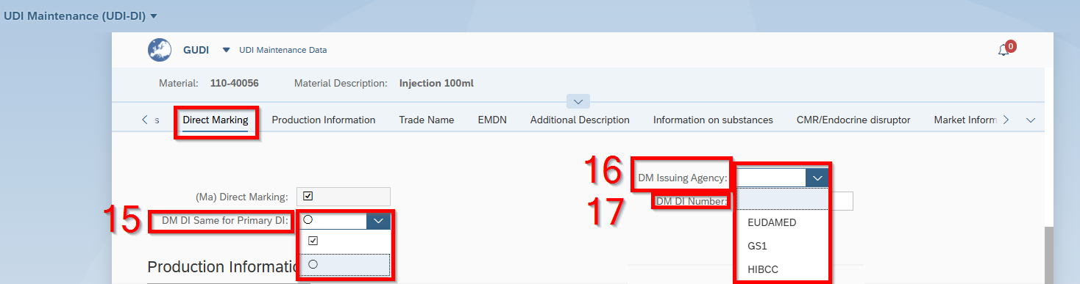
- Choose “DM DI Same for Primary DI” yes or no
- Choos “DM Issuing Agency”
- Fill in “DM DI Number”

Production Information

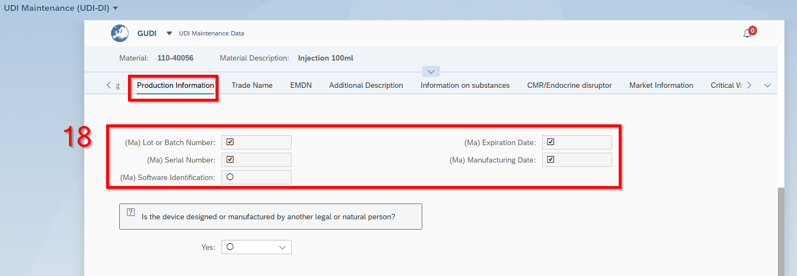
- Comes from Master UDI. No actions here.

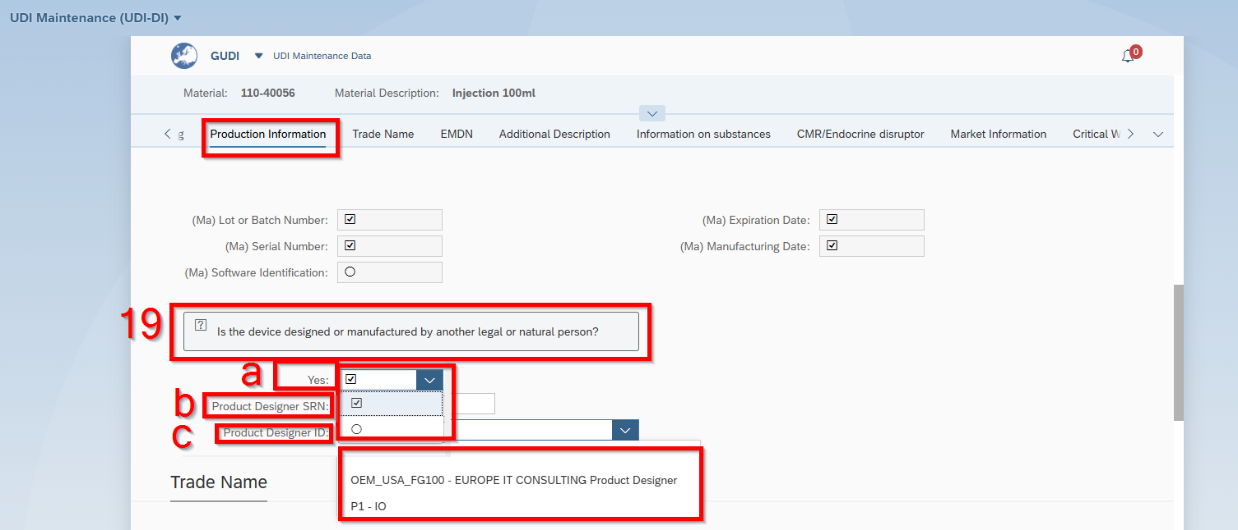
- a Choose yes or no
b If yes, fill in “Product Designer SRN”
c Choose “Product Designer ID”

Trade Name

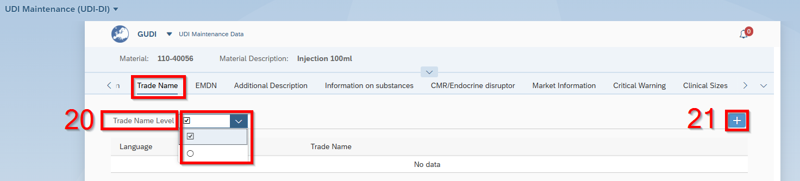
- Choose “Trade Name Level” yes or no
- If yes, click on “+”

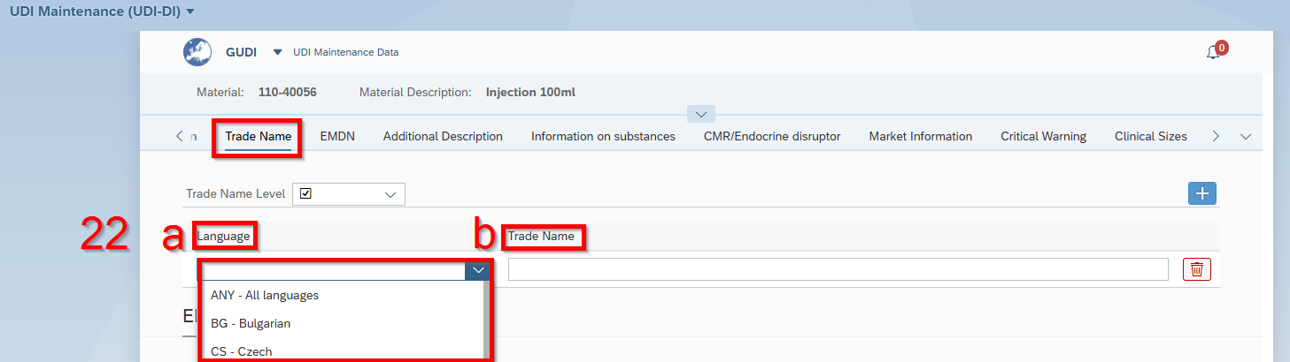
- a Choose “Language”
b Fill in “Trade Name”

EMDN

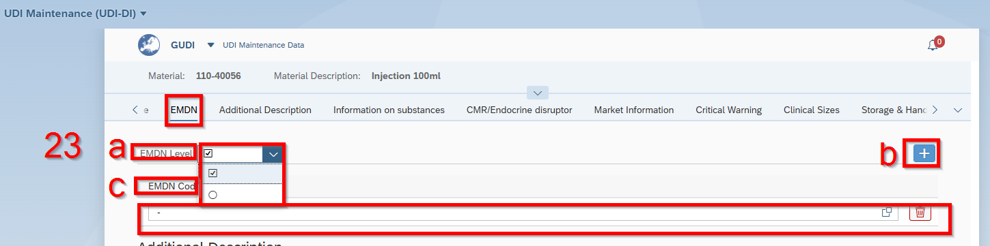
- a Choose “EMND Level” yes or no
b If yes, click on “+”
c and d “EMDN Code”

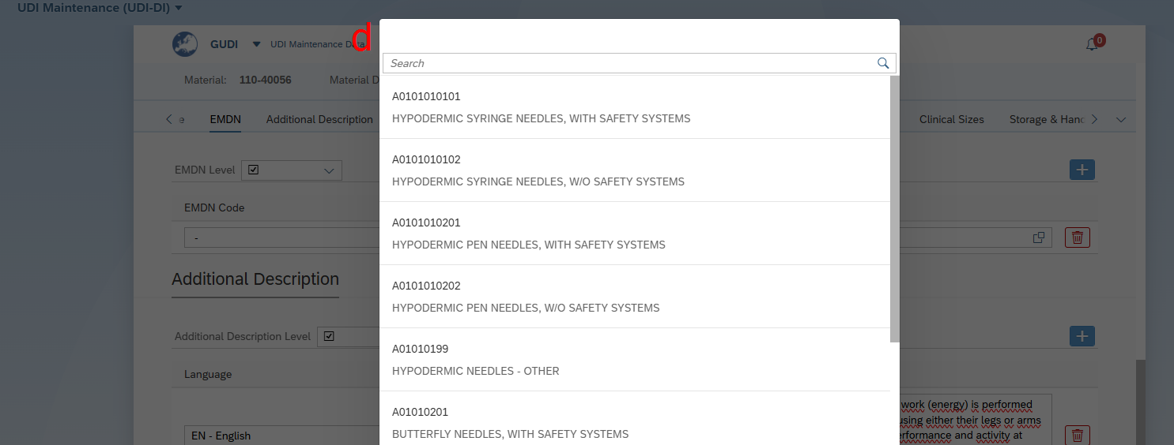

Additional Description

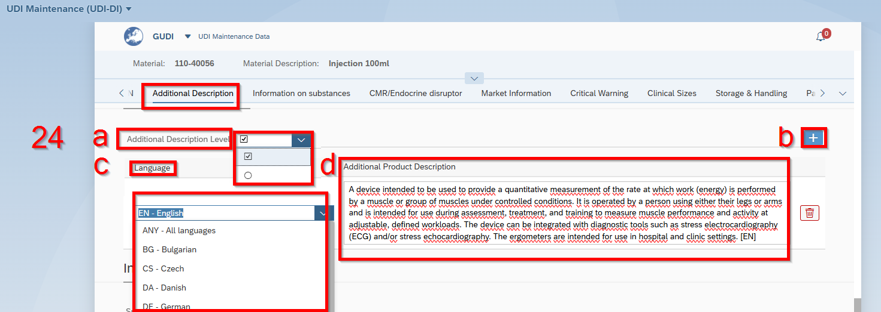
- a Choose “Additional Description Level” yes or no
b If yes, click on “+”
c Choose “Language”
d Fill in “Additional Product Description”

Information on substances

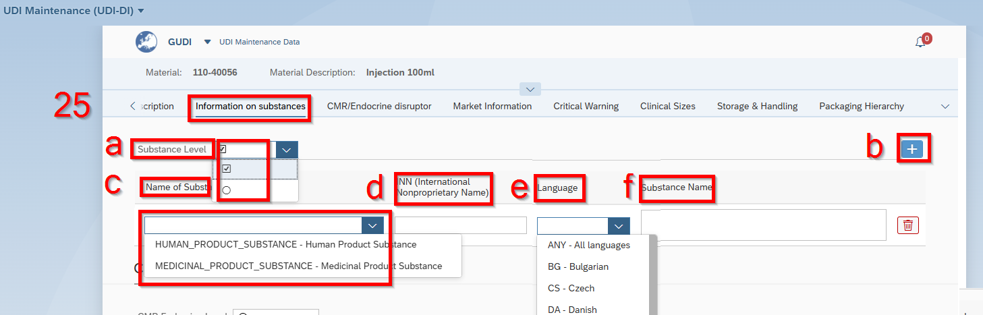
- a Choose “Substance Level” yes or no
b If yes, click on “+”
c Fill in “Name of Substance”
d Choose “NN (International Nonproprietary Name)”
e Choose “Language”
f Fill in “Substance Name”

CMR/Endocrine disruptor

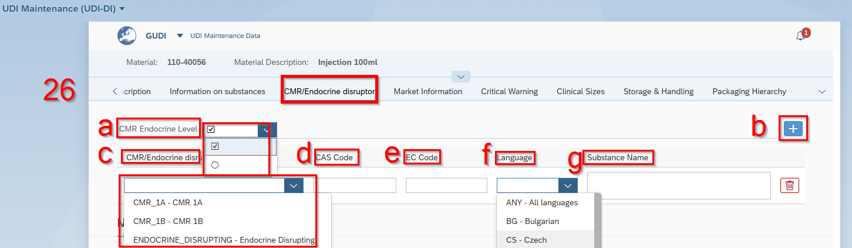
- a Choose “CMR Endocrine Level” yes or no
b If yes, click on “+”
c Choose “CMR/Endocrine”
d Fill in “CAS Code”
e Fill in “EC Code”
f Choose “Language”
g Fill in “Substance Name”

Market Information

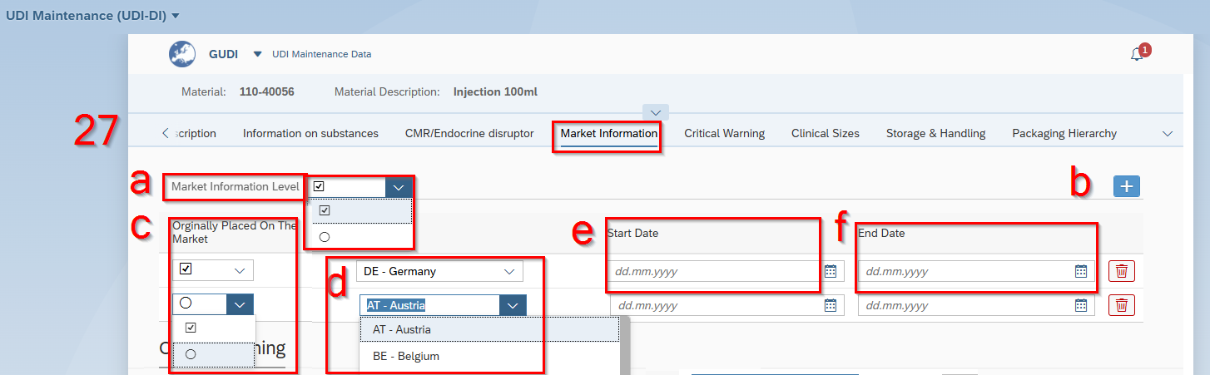
- a Choose “Market Information Level” yes or no
b If yes, click on “+”
c Choose “Originally Placed on the Market” yes or no
d Choose “Language”
e Fill in “Start Date”
f Fill in “End Date”

Critical Warning

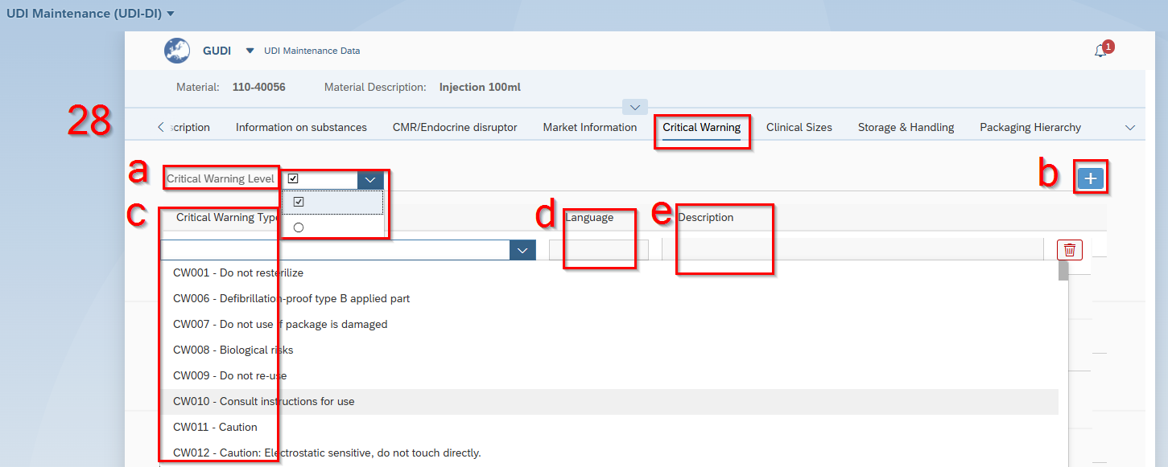
- a Choose “Critical Warning Level” yes or no
b If yes, click on “+”
c Choose “Critical Warning Type”
d Choose “Language”
e Fill in “Description”

Clinical Sizes

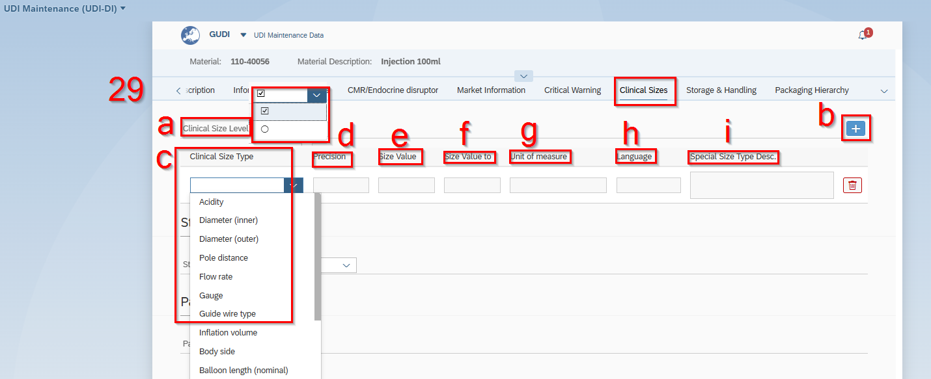
- a Choose “Clinical Size Level” yes or no
b If yes, click on “+”
c Choose “Clinical Size Type”
d Fill in “Precision”
e Fill in “Size Value”
f Fill in “Size Value to”
g Fill in “Unit of measure”
h Choose “Language”
i Fill in “Special Size Type Description”

Storage & Handling

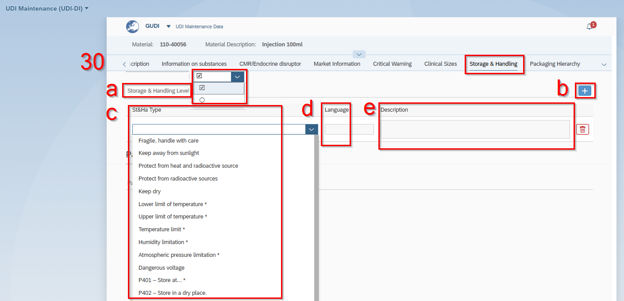

- a Choose “Store & Handling Level” yes or no
b If yes, click on “+”
c Choose “St&Ha Type”
d Fill in “Language”
e Fill in “Description”

Packaging Hierarchy

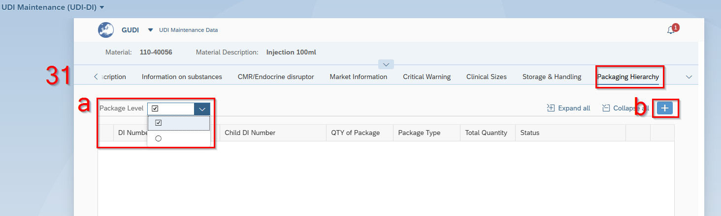

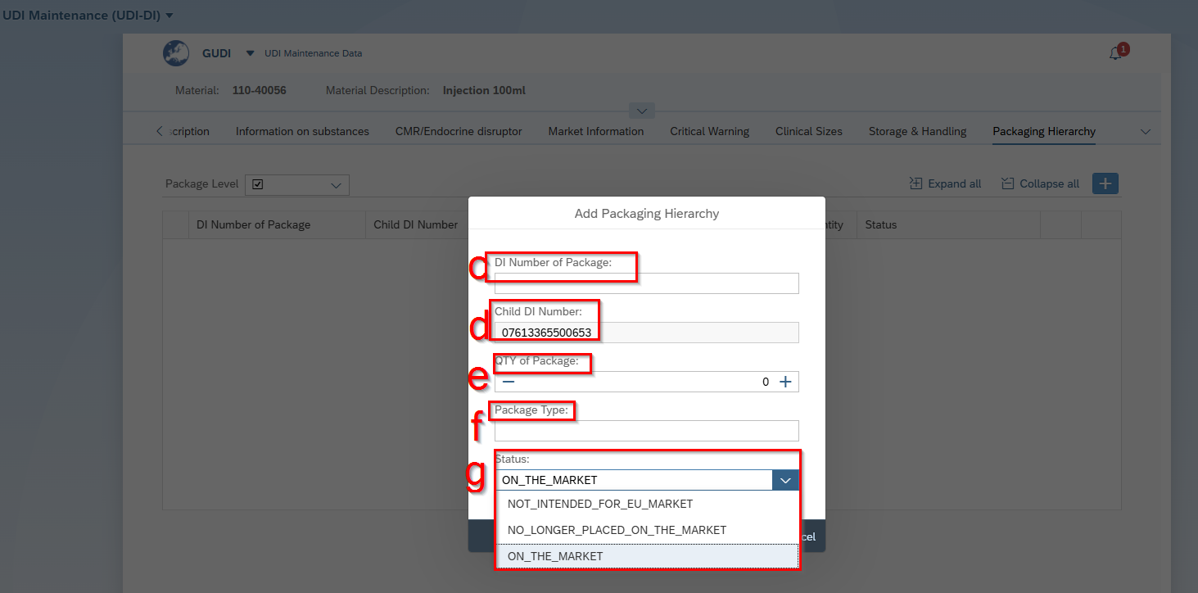
- a Choose “Pacakge Level” yes or no
b If yes, click on “+”
A new window pops up.
c Fill in “DI Number of Package”
d Fill in “Child DI Number”
f Increase (Decrease) “QTY of Package”
g Choose “Status”

Validation

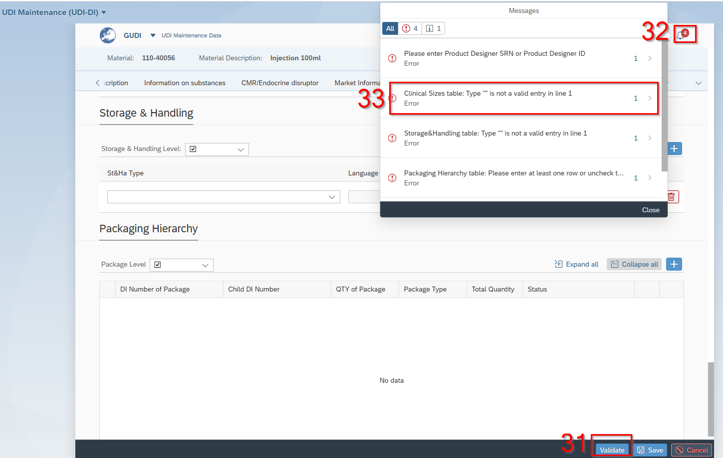
- Click on “Validate”, continue with clicking on the bell
- Click on one of the mistakes and correct it.

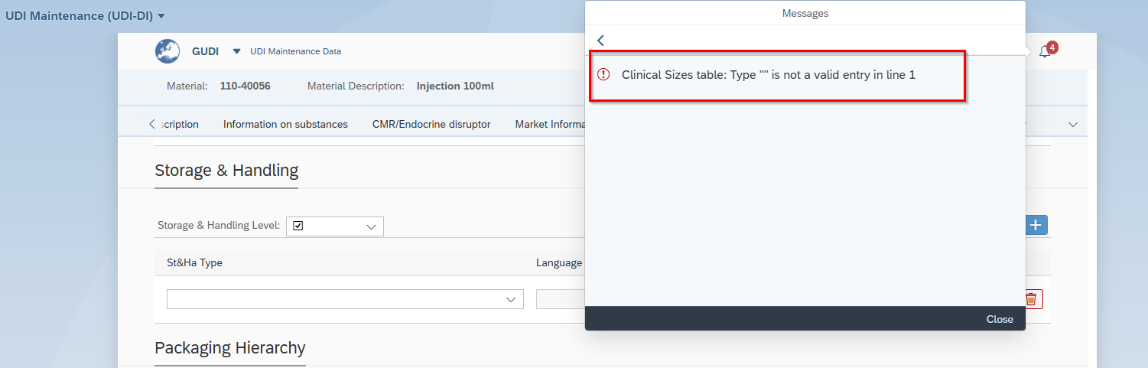

Save

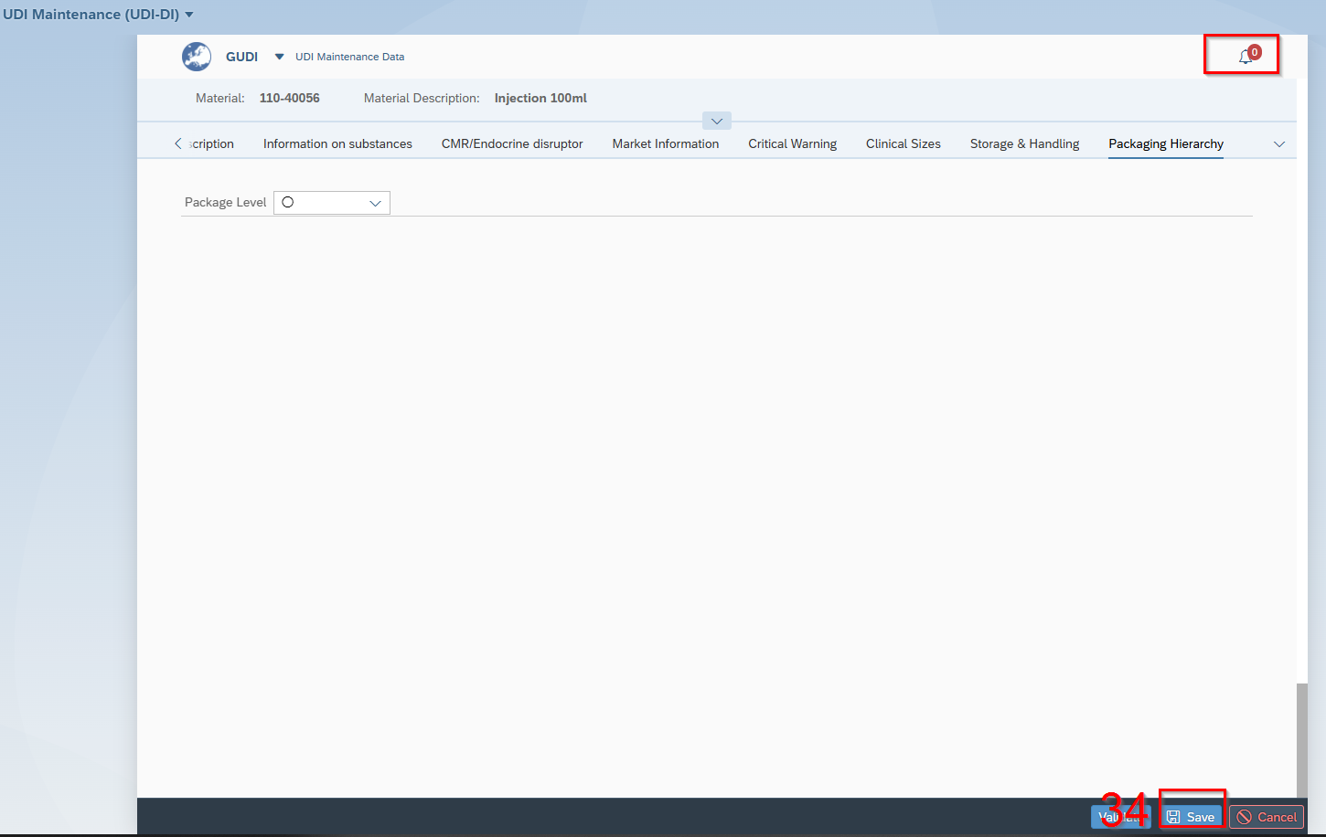
- Click on “Save”

Start Release Workflow of UDI-DI

- Access the "Start Release Workflow" Application.

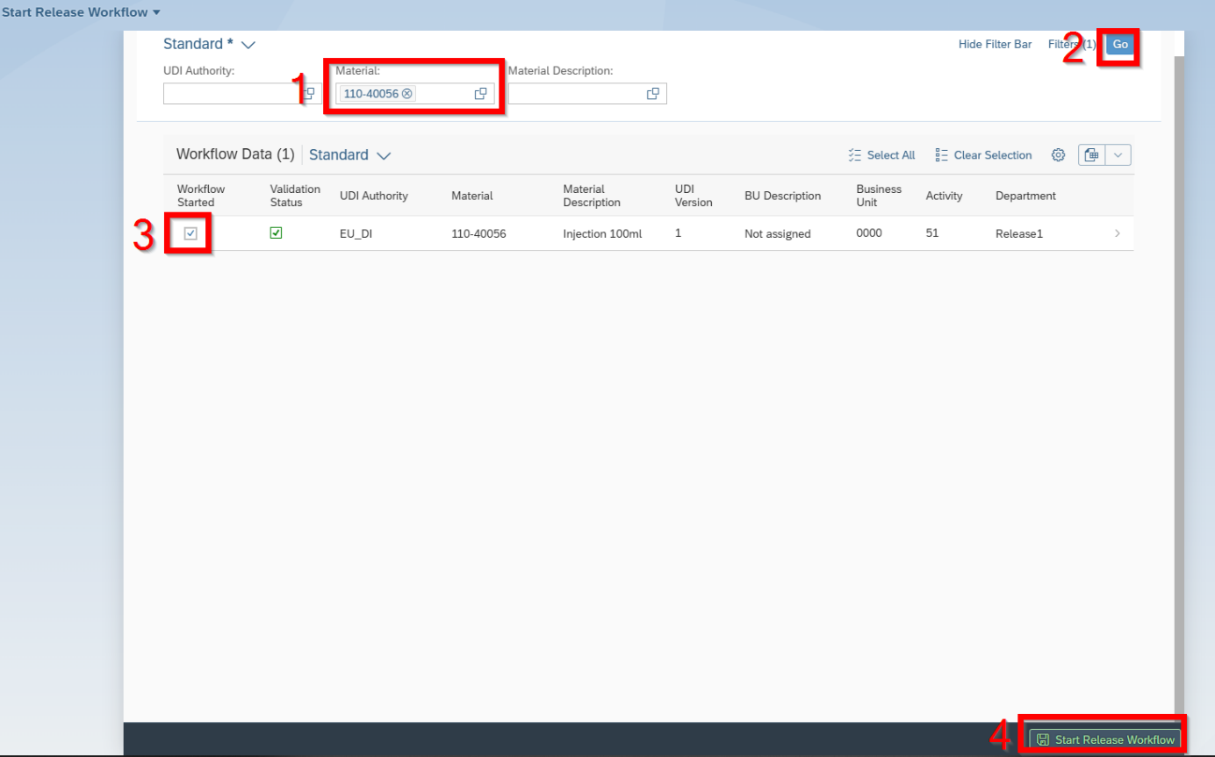
- Write material number in that field
- Click Go
- Click on Active
- Start Release Workflow

Release the UDI-DI

- Access the "Release UDI Data" Application.

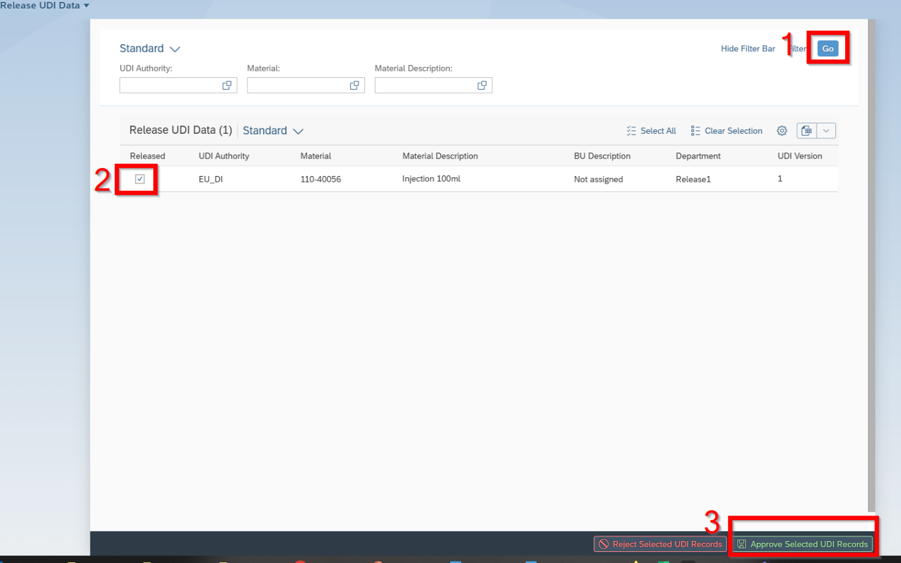
- Click on „Go“
- Select the UDI-DI
- Click on „Approve Selected UDI Records“

Data submission

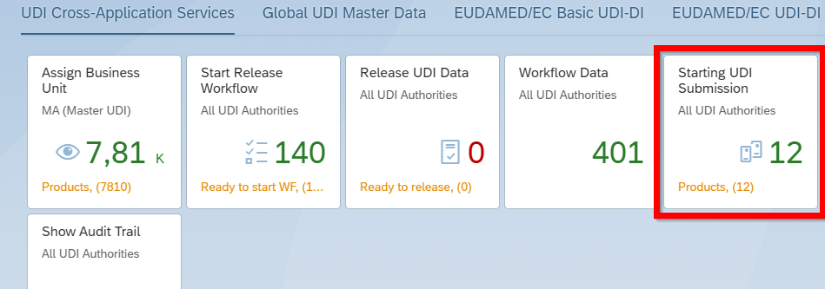
- Access the "Starting UDI Submission" Application.

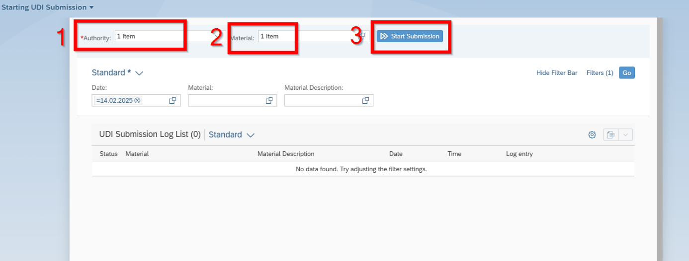

- Choose the „Authority“
- Fill in the UDI-DI
- Click on „Start Submission“

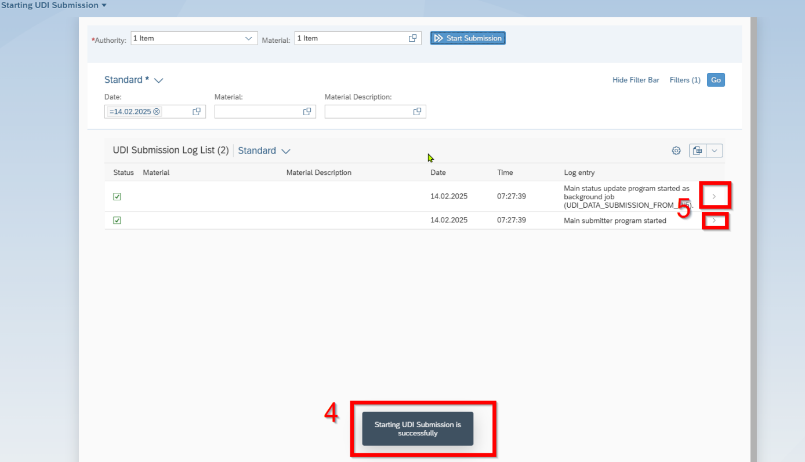

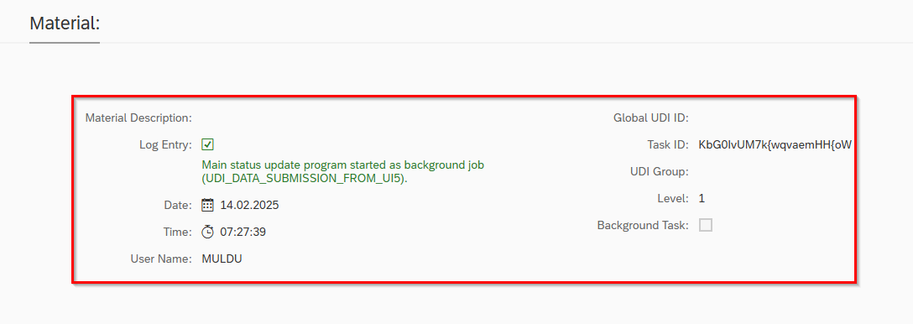
- Message pops up
- Fill in the UDI-DI
- Click on „Start Submission“

